Inventory Alternate Parts and Comments Screen: This file pulls data from the Alternate Part Numbers and Comments sections of the Parts Master.

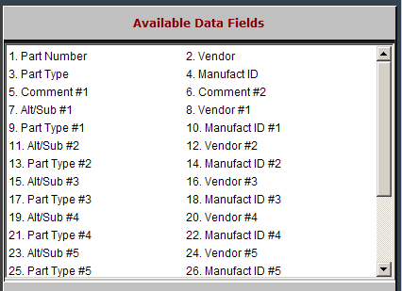

Part Number: The 20-digit alpha-numeric Part Number field holds the complete part number.

Vendor: This three-digit number identifies the manufacturer of the part number.

Part Type: The type code identifies what the part is. It can be:

N= New

R= Rebuilt or Remanufactured

C=Core

U=Used

M=Memo.

Manufact ID: The manufacturer ID is provided from certain manufacturer price files.

Comment #1, Comment #2: These are two lines available for comments about this part. They can be printed on POS Invoices and parts order printouts.

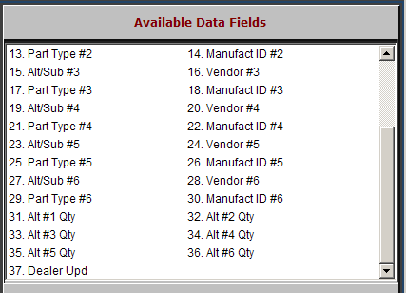

Alt/Sub #1 – 6: This collection of up to six fields can hold information about alternate part numbers. This information is dealer maintained and the part numbers referenced here do not have to be in your inventory.

Vendor #1 – 6: This collection of up to six fields can hold the vendor number for alternate part numbers.

Part Type #1 – 6: This collection of up to six fields can hold the part type for alternate part numbers.

Manufacturer ID #1 – 6: This collection of up to six fields can hold the manufacturer ID for alternate part numbers.

Alt Qty 1 -6: This collection of up to six fields can hold the quantity for alternate part numbers.

Dealer Upd: This field shows a “d” if the information about alternate numbers was entered by the dealer.

In isolated cases, you might find an “m,” which indicates the manufacturer provided the information some time back.

