Inventory Source Factoring: This file pulls data from the Source Factor portion (price tiers) of the Source Master Record.

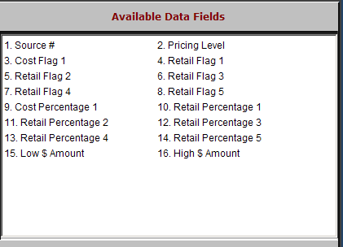

Source #: The Source Number is a three-digit number which identifies the manufacturer or vendor for this source of parts. Usually, the Source Number is the number of the corresponding price file.

Sometimes additional sources for the same vendor are added when there are multiple pricing schemes or ordering differences within that vendor’s parts.

Pricing Level: The Pricing Level field contains a number from 01-99. These price levels are simply a definition of a series of dollar ranges based on the MSRP of the parts for this source number. Each source MUST have at least ONE price level.

Cost Flag 1: This field identifies how cost is based for this price level of this source. It may be a value from 1 – 6.

Retail Flag 1–4: These fields identify what these price codes are based on for this price level with this source. They may be a value from 1 – 6.

Retail Flag 5: This field identifies what the MSRP or book price is based upon. It may be a value from 1 – 6.

Cost Percentage 1: This field is a three-digit number and is multiplied against the value in the price flag field for this level for this source.

If it is based on cost (1), it is typically 100.

If it is based on MSRP/Book (2), it is typically a number less than 100.

Retail Percentage 1 – 5: These fields hold a three-digit number that is multiplied against the value in the price flag field for this level for this source.

A value of 100 in this field means that the value in the price flag field is itself.

A value higher than 100 means the price flag value is being marked up.

Low $ Amount: The amount in this field represents the beginning value of the price tier defined.

High $ Amount: The amount in this field represents the ending value of the price tier defined.

