Source (Manufacturer Info): This file pulls data from the Source Master record.

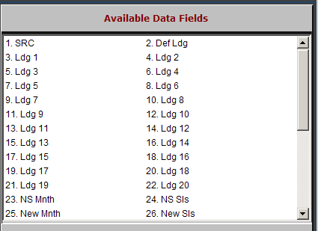

SRC: This field holds a three-digit number which identifies the manufacturer or vendor for this source of parts.

Def Ldg: If an incorrect Sales Code is selected or the part number shows an invalid Source Number when an invoice is written, the system posts the sales amount to the ledger number named in this field. Usually, account number 34993 is used here.

Ldg 1 – 20: Each field represents a Sales Code and holds a General Ledger account number that defines that Sales Code. For example, Ledger 1 represents Sales Code 01. Each sales transaction uses one of these fields to pass the accounting information to its proper place.

NS Mnth: The NS Months (number of stocking months) is the range of months that determines the stock class for parts in this source. Typical choices for this field are 12 to 60 months. This number indicates the number of months used to determine if a part is considered a fast moving or non-stock part.

NS Sls: The NS Sales (number of stocking sales) is the number of months with actual sales used for calculating the stock class. Sales activity is based on months with sales activity, not on the number of units sold.

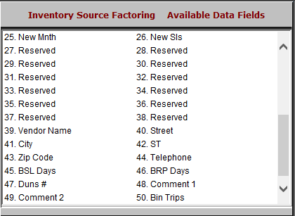

New Mnth: This field applies ONLY to inventory with a Stock Class of 6. It specifies how long a new part added to the system will be kept at a Stock Class of 6, if so allocated, by indicating a number of months.

When the new part reaches the number of months entered here, the Month End process will upgrade or downgrade its stock class based on its performance and the value entered in the New Sales field.

New Sls: This field applies ONLY to inventory with a Stock Class of 6. It works with the New Months field to set the number of months with actual sales activity.

The Stock Class 6 part must have sales activity in the number of months entered here to qualify for fast moving status.

Reserved: These fields are reserved for future use.

Vendor Name: This field holds the vendor or manufacturer’s name.

Street: The Source Street field holds the vendor or manufacturer’s actual street address.

City: This field holds the vendor’s city name.

ST: The Source State field is for the vendor’s state or province. It holds the standard two-letter abbreviation.

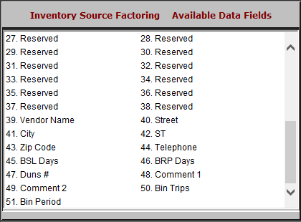

Zip Code: The vendor's Zip Code or Postal Code is kept in this field. It holds 10 characters for extended U.S. Zip Codes and Canadian Postal Codes.

Telephone: The Telephone Number field holds the vendor/manufacturer’s telephone number.

BSL Days: The BSL (Best Stocking Level) field shows the stock to keep on hand in terms of days supply. It works closely with the Best R.P. (Best Reorder Point) field to set the amount of stock to keep on hand and when to reorder.

BRP Days: The Best R.P. (Best Reorder Point) is the lowest level of on-hand stock to reach before it triggers an order. Like the Best Stocking Level, it measures your stock in days supply. This field is checked to see if the days supply has dipped to this level, meaning it’s time to reorder.

Comment 1 – 2: These two fields hold any comments about the Source, the manufacturer, your ordering notes, etc.
- Bin Trips: The Bin Trip Level field indicates the number of bin trips over a certain period of time which will trigger a stock order.
- Bin Period: The Bin Trip Period indicates, in months, the time frame used to determine the Bin Trip Level.

