Parts Vendor File: This file pulls data from the Parts Vendor file.

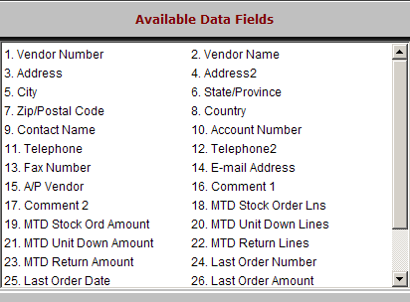

Vendor Number: This three-digit number identifies the vendor/manufacturer for this line of parts.

Vendor Name: The vendor's name appears in this field.

Address: The vendor's mailing address appears in this field.

Address2: This field holds the second line of the vendor’s mailing address.

City: This field holds the vendor's city.

State/Province: This field holds the vendor’s state or province abbreviation.

Zip/Postal Code: This shows the vendor's country code or zip/postal code.

Country: This shows the three-character country abbreviation, such as USA, CAN, MEX, etc.

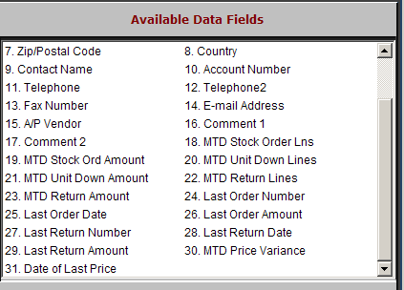

Contact Name: This field can store a contact name for the vendor.

Account Number: This field holds your account number with this vendor.

Telephone: This field shows the company's main telephone number.

Telephone2: This field provides space for an additional phone number for the vendor.

Fax Number: The vendor's fax number is held in this field.

E-mail Address: The vendor’s email address is kept in this field.

A/P Vendor: This field can store the A/P five-digit Vendor Account Number.

Comment 1 – 2: These fields hold any comments or notes about the Vendor.

MTD Stock Order Lns: This field collects the number of lines (individual part numbers) of stock orders received for the current month.

MTD Stock Ord Amount: This field shows the total dollar value of the stock orders received for the current month.

MTD Unit Down Lines: This field collects the number of lines (individual part numbers) of unit down orders received for the current month.

MTD Unit Down Amount: This field shows the dollar value of the unit down orders received for the current month.

MTD Return Lines: This field collects the number of lines (individual part numbers) of parts returns recorded for the current month.

MTD Return Amount: This field shows the dollar value of the parts returns recorded for the current month.

Last Order Number: This shows the last parts order number received.

Last Order Date: This shows the date of the last parts order received.

Last Order Amount: This shows the value of the last parts order received.

Last Return Number: This shows the last parts return number processed.

Last Return Date: This shows the date of the last parts return processed.

Last Return Amount: This shows the value of the last parts return processed.

MTD Price Variance: This field shows the dollar value of the change in inventory due to running Price Update and Variance (probably because of loading a new price file).

Date of Last Price: This field shows the date of the last change in inventory due to running Price Update and Variance.

