Parts Order File: This file pulls data from the Parts Order file.

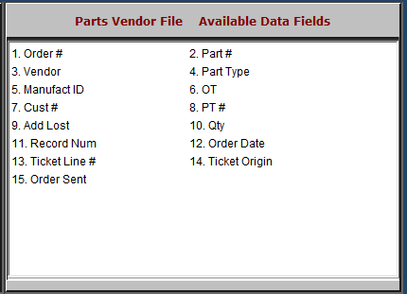

Order #: This field shows the order number.

Part #: This field shows the part number on order.

Vendor: This field shows the vendor number for the part.

Part Type: This is the part type from the part master. It can be:

N=New

U=Used

C=Core

R=Remanufactured

M=Memo.

Manufact ID: This field may hold the manufacturer ID of the ordered part, if provided by the vendor.

OT: This field shows the Order Type. This could be:

N=New

C=Customer

E=Emergency

B=Backorder.

Cust #: This field contains the customer number of the customer who ordered the part, if the order part is “C.”
- PT #: If the order originated from a POS/SMS backorder, that picking ticket number will appear here.

Add Lost: This field is reserved for future use.

Qty: This field shows the quantity on order or back order.

Record Num: This field is reserved for future use.

Order Date: This field shows the date the order was created.
- Ticket Line #: This field is reserved for future use.
- Ticket Origin: This field is reserved for future use.
- Order Sent: This field shows “Y” if the flag for Order Sent is active in Parts Order. Otherwise, it is blank.

