Parts Return File: This file pulls data from the Parts Return file.

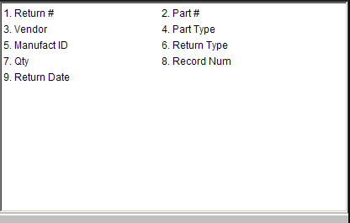

Return: This field holds the return number.

Part #: This field lists the part numbers found on this Return.

Vendor: This field lists vendor numbers for the part numbers.

Part Type: This field lists the Part Types, which can be:

C=Core

M=Memo

N=New

R=Remanufactured

U=Used.

Manufact ID: This field shows the manufacturer ID of the part, if any.
- Return Type: This field lists Return Types, which are:
  - A = Annual
  - S = Special
  - C = Close Out
  - T = Dealer Trade.

Qty: This field lists the quantity to be returned to the manufacturer.

Record Num: This field is reserved for future use.

Return Date: This field lists the date(s) for the Return(s).

