Inventory Transaction File: This file pulls data from the Parts Inventory Transaction file.

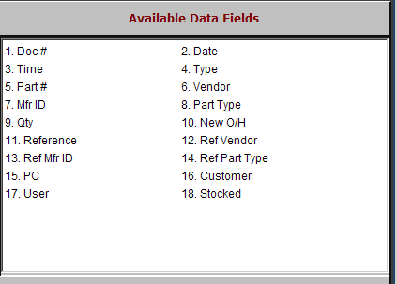

Doc #: This is the Invoice number or type of change that occurred with this part number.

Date: This field shows the date that the change took place.

Time: This field shows the time that the change took place.

Type: This field shows the type of transaction that occurred. These types are:

A=Adding a New Part

C=Clear Flag for Part Deletion

D=Delete a Part

F=Flag a Part for Deletion

H=Parts On Hand Adjusted

I=Invoice Printed, L=Lost Sale

M=Manual Price File Change

P=Part Number Change

O=Stock Order

R=Receipt

S=Part Sales

T=Part Transfers

V=Voided Parts Sales

Part #: This field shows the part number that had changes made to it.

Vendor: This field shows the vendor number assigned to this part number.

Mfr ID: This field shows the manufacturer ID assigned to the part, if applicable.

Part Type: This field lists the part type, which can be:

C=Core

M=Memo

N=New

R=Remanufactured

U=Used.

Qty: This field shows the quantity of the transaction listed on the report.

New O/H: This field shows the quantity on hand AFTER the change was recorded.

Reference: This field is reserved for future use.

Ref Vendor: This field is reserved for future use.

Ref Mfr ID: This field is reserved for future use.

Ref Part Type: This field is reserved for future use.

PC: This field is reserved for future use.

Customer: If this part was put on a picking ticket for a customer, this field shows their account number/customer number.

User: This field shows the login information (ID) for the person that made this change.

Stocked: This field indicates whether or not this part is carried in inventory.

“YES” means it is a stocking part

“NO” means it is non-stocking part.

The majority of these will be “space O” parts.

