POS History Summary: This file pulls data from the summary of the POS History file.

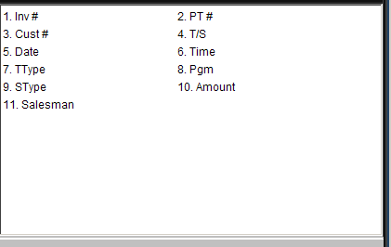

Inv #: This field shows the invoice number assigned by the system when the ticket was written.

PT #: This field shows the Picking Ticket Number before it was closed and written as an invoice.

Cust #: This field shows the customer’s account number.

T/S: This field shows the type of sale that was on the POS invoice. For example: Cash, Charge, Farm Plan, Visa, Mastercard, other credit cards, etc.

Date: This field shows the date of the invoice.

Time: This field shows the time the invoice was written on the date shown (POS Invoices only).

TType: This field shows the transaction type, which could be:

I=POS Invoice

V=POS voided invoice

P=SMS Invoice.

Pgm: This field indicates where the transaction originated, which could be:

I=POS Invoice

C=SMS Invoice.

Stype: This field is reserved for future use.

Amount: This field shows the amount of the invoice.

Salesman: This field holds the salesman’s initials or number.

