Salesman Commission Report File: This file pulls information from the Salesman Commission File.

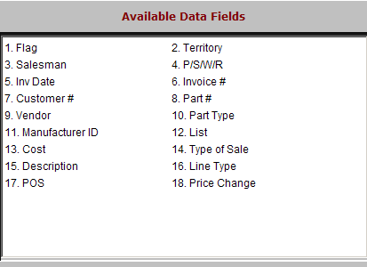

Flag: This field is reserved for future use.

Territory: This field shows the customer’s territory code when the invoice was processed.

Salesman: This field shows the initials or number for the salesperson.

P/S/W/R: This field shows the type of activity. Values are:

P = Part

S = Service

W = Wholegoods

R = Rental.

Inv Date: This field holds the invoice date.

Invoice #: This field holds the invoice number.

Customer #: This field holds the customer’s assigned account number.

Part #: This field shows the part number, if any.

Vendor: This field holds the vendor number for the part.

Part Type: This field shows the part type, which could be:

New

Used

Core

Reman (for “Remanufactured”)

Memo

Manufacturer ID: This field holds the manufacturer ID for the part.

List: This field holds the selling price of the item.

Cost: This field holds the item’s cost when it was sold.

Type Of Sale: This field shows the type of sale, which could be:

Cash

Charge

Credit card.

Description: This field shows a description of either:

The part number sold

The line item.

Line Type: This field may show the type of transaction, which could be:

L=Labor

W=WG

T=Tax

E=Non-part number item.

POS: This field may identify something about the transaction. For example, 1-part number, 2-part number lines, 3-special billing terms, x-tax, etc.

Price Change: This field is reserved for future use.

