Parts Month End Total File: This file pulls data from the Parts Month End file.

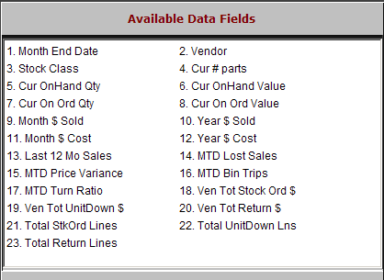

Month End Date: This field shows the date of parts month end.

Vendor: This field holds the vendor number.

Stock Class: This field shows the stock class designation for the parts of this vendor.

Cur # Parts: This field shows the number of part masters for this vendor.

Cur OnHand Qty: This field shows the on-hand quantities for this vendor.

Cur OnHand Value: This field shows the inventory value for this vendor.

Cur On Ord Qty: This field shows the quantity of parts on order for this vendor.

Cur On Ord Value: This field shows the dollar value of parts on order for this vendor.

Month $ Sold: This field lists the month’s sales for this vendor in actual dollars.

Year $ Sold: This field lists the vendor’s total sales dollars for the calendar year.
- Month $ Cost: This field lists the month’s cost of sales for this vendor in actual dollars.

Year $ Cost: This field lists the vendor’s total cost of sales for the calendar year.

Last 12 Mo Sales: This field lists the Vendor’s total sales for the last 12 month period.

MTD Lost Sales: This field lists the value of parts that had lost sales for the month shown

MTD Price Variance: This field shows the change in value of the inventory due to running Price Update and Variance.

MTD Bin Trips: This field shows the number of bin trips for this vendor for the month shown.

MTD Turn Ratio: This field shows the turn ratio for this group of parts for the month shown.

Ven Total Stock Ord $: This field shows the value of stock orders received for the vendor.

Ven Tot UnitDown $: This field shows the value of unit down orders received for the vendor.

Ven Tot Return $: This field shows the value of returns processed for this vendor.

Total StkOrd Lines: This field shows the number of stock order items received for the vendor.

Total UnitDown Lns: This field shows the total number of units down items received from this vendor.

Total Return Lines: This field shows the total number of items on processed parts returns for this vendor.

