POS Environmental Charge File: This file pulls data from the Environmental Charges File.

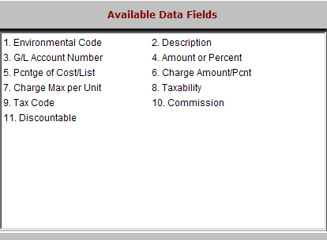

Environmental Code: This five-digit alphanumeric code identifies the particular environmental fee.

Description: The description field provides a brief definition of the environmental charge.

G/L Account Number: This field holds the General Ledger account number where the environmental charges will be collected.

Amount or Percent: This field shows how the charge is based. It is either:

A=Amount

P=Percentage.

Pcntge of Cost/List: If the charge is percentage based, the field indicates what field is used to calculate it:

C=Cost

L=List.

Charge Amount/Pcnt: This field holds either:

The amount of the charge

The percentage used to calculate

Charge Max per Unit: This field may show the maximum dollar amount that can be assessed for this charge.

Taxability: This field determines if you will charge tax or not on the fee.

“N” means never taxable.

“C” means it is taxed according to the customer’s tax status.

“Y” means always taxable.

Tax Code: This field is used when the charge is always taxable and holds the appropriate tax code.

Commission: This field shows if the charge is eligible for commission.

“Y” means it can be included in the commission calculation.

Discountable: This field shows if the charge can be discounted:

Y=Discountable

N=Cannot Be Discounted.

