POS Environmental Charge Transactions: This file pulls data from the Environmental Charge Transactions File.

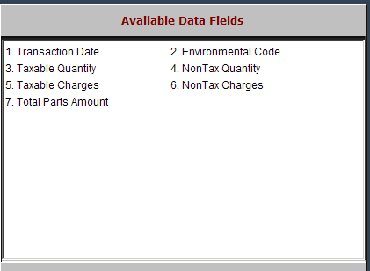

Transaction Date: This field shows the date of the transaction.

Environmental Code: This column shows the environmental charge code.

Taxable Quantity: This field shows the quantity of taxable environmental charges sold on the invoice.

NonTax Quantity: This field shows the quantity of non-taxable environmental charges sold on the invoice.

Taxable Charges: This field shows the dollar amount of taxable environmental charges sold.

NonTax Charges: This field shows the dollar amount of non-taxable environmental charges sold.

Total Parts Amount: This field shows the amount of Parts Sales dollars that generated the environmental charges shown.

