Sales Tax Rate File: This file pulls data from the Sales Tax Rate File.

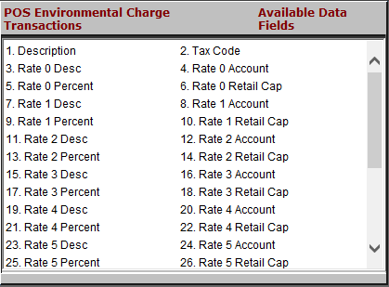

Description: This field holds the description of the tax code.

Tax Code: This field holds the number of the tax code.

Rate 0 - 9 Desc: This series of ten fields may hold:

A detailed description of the code

A portion of the tax, if it is divided across several rates.

Rate 0 - 9 Account: This series of ten fields may hold:

The G/L account where tax for this rate is collected

A portion of it, if the tax is divided across several rates.

Rate 0 - 9 Percent: This series of ten fields may hold:

The percentage of tax for this rate

A portion of it, if the tax is divided across several rates.

Rate 0 - 9 Retail Cap: This series of ten fields may hold:

The maximum retail amount that can be taxed if there is a limit for this rate

A portion of the rate, if it is divided across several rates.

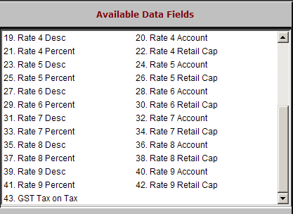

GST Tax on Tax: This field holds the setting for when PST is to be calculated on GST.

“Y” means it will be calculated on GST

“N” means it will not.

