Accounts Receivable Open Invoices: This file pulls data from the Accounts Receivable Open Invoices file.

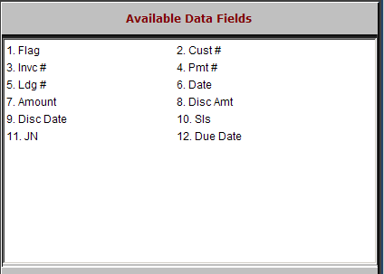

Flag: This field is reserved for future use.

Cust #: This field holds the unique five-digit number for this customer.

Invc: This field shows the invoice number on the customer’s account.

Pmt #: If there has been a payment on this invoice, this field shows the reference number for that payment.

Ldg #: This field shows the general ledger account affected by the transaction.

Date: This field shows the date of the transaction.

Amount: This field shows the amount of the transaction.

Disc Amt: This field is reserved for future use.

Disc Date: This field is reserved for future use.

Sls: This field may show the salesman’s initials.

JN: This field shows the journal where the transaction was processed.

Due Date: If the transaction was processed as future billing, then this field shows the due date.

