Accounts Receivable Customer Master: This file pulls data from the A/R Customer Master.

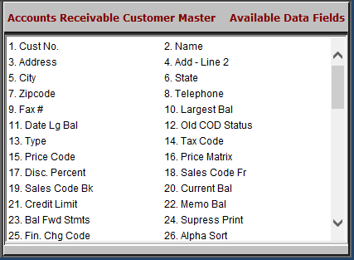

Cust No.: This field holds the unique five-digit number for this customer.

Name: This field holds the customer’s name.

Address: This space holds the customer’s mailing address.

Add – Line 2: This field provides an additional line for the customer’s address.

City: This field holds the city where the customer receives mail.

State: This field holds the two character abbreviation for the customer’s state or province.

Zipcode: The zip code field is nine positions and will accommodate both the expanded U.S. Zip Codes and Canadian Postal Codes.

Telephone: This area holds the customer’s telephone number, including area code.

Fax #: This field shows a fax number for the customer.

Largest Bal: This field holds the amount of the Largest Balance held by the customer.

Date Lg Bal: This field holds the date corresponding to the Largest Balance shown in the Largest Bal field.
- Old COD Status: This field shows the customer’s old COD status. The options are defined as follows:
  - Y – Cash only
  - N – Not on COD
  - F – Farm Plan Customer
  - D – Discover Card
  - A – American Express
  - M – Mastercard
  - V – Visa
  - E – Case
  - P – Farm Plan Card-Purchase Plus
  - H – New Holland
  - G – AGCO Agricredit
  - Z – AGCO Agricard
  - Other point of sale form of payment:
    - L – Polaris
    - K – Freedom Card
    - W – Warranty
    - I – Internal

Type: For Case dealers, this field defines the customer type of this customer record. This information is used for the Case Salesmaker Customer Extract program. The definitions are as follows:
  - S - Sole Proprietary
  - I - Individual
  - C - Corporation
  - G - Government
  - P - Partnership
  - R - Rental Yard

Tax Code: This field holds the primary or typical tax code for this customer.

Price Code: This field holds the basis for pricing for the customer. It works with the Discount Rate field to determine the selling prices for pre-priced items in POS and SMS. The choices for this field are:
  - 1 - Cost
  - 2 - List
  - 3 - Dealer Defined Pricing Level
  - 4 - Dealer Defined Pricing Level
  - 5 - Dealer Defined Pricing Level
  - 6 - MSRP (Manufacturer’s Suggested)

Price Matrix: This field is used to point to a defined price matrix code

Discount Percent: A percentage shown here provides a discount on all pre-priced items in POS and SMS.

Positive numbers are discounts

Negative numbers are a bump to the price.

Sales Code Fr: This field holds the default sales code used when the customer makes purchases at the parts counter. Sales codes provide the pointer to the general ledger account number to receive the dollars from the service sales transaction.

Sales Code Bk: This field holds the default sales code used when the customer makes purchases in the Service Department (on a repair order). Sales codes provide the pointer to the general ledger account number to receive the dollars from the service sales transaction.

Current Bal: This is a system-maintained field that displays the posted balance for this customer. It includes only transactions that have been posted from the Parts, Service Units, and Rental invoicing routines and payments on account from Cash Applications and GLED/ARDI.

Credit Limit: This field refers to the maximum amount of credit extended to this customer.

Memo Bal: This is a system-maintained field that displays the total balance for this customer. This balance consists of the posted balance (Current Bal) plus the unposted entries made through POS and SMS invoicing or Cash Applications

Bal Fwd Stmts: The choice entered in this field determines the type of detail shown on the customer’s statement.

“Y” means the statement preference is balance forward.

“N” means the statement preference is open item.

Suppress Print: This field offers the choice of whether or not to print a statement for this customer.

“Y” means the statement is suppressed.

“N” means it will print.

Fin. Chg Code: This field holds the code for the finance charge rate for this customer dealership. It can be 00–09.

Alpha Sort: This field is used to provide the look-up feature for customer names/numbers and to sort customer information alphabetically for reports. It is an 8-character field.

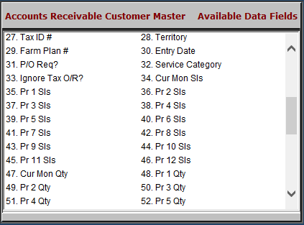

Tax ID #: This field stores the customer’s tax exempt number.

Territory: This field can be used to categorize customers by any grouping that is appropriate for the dealership.

Farm Plan #: This field is valid only for Farm Plan customers. It holds the customer’s full Farm Plan account number.

Entry Date: This field holds the date the customer record was added or when the customer first starting doing business with the dealership.

P/O Req?: This field shows whether or not the customer requires a purchase order number on an invoice.

Service Category: This field is used by the Service Management System to classify the typical sales tax category that this customer uses. SMS typically defines:

The taxable customers as 01

The nontaxable customers as 02.

Ignore Tax O/R?: This field helps you specify the customer’s sales tax situation applying to parts and service transactions, and allows the customer’s sales tax code to override any codes found on part numbers.

Cur Mon Sls: This field shows the amount of charge and credit card purchases made for the month.

Pr 1 Sls - Pr 12 Sls: This is a series of 12 fields that show the amount of charge and credit purchases made by the month. Pr1 Sls is last month, Pr2 Sls is two months ago, etc.

Cur Mon Qty: This field shows the number of charge and credit transactions for this month.

Pr 1 Qty – Pr 12 Qty: This series of 12 fields shows the number of charge and credit card transactions by the month. Pr 1 qty is last month, Pr 2 qty is two months ago, etc.

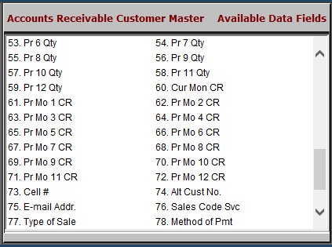

Cur Mon CR: This field shows the customer’s credit rating for this month.

Pr Mo 1 CR – Pr Mo 12 CR: This series of 12 fields shows the credit rating for the month. Pr Mo 1 CR is last month, Pr Mo 2 CR is two months ago, etc.

Cell #: This field holds the customer’s cell phone number.

Alt Cust No.: This field can hold the customer number from a previous business system.

E-Mail Address: This field provides space to enter the customer’s email address. The information is also viewable in the Customer Master.

Sales Code Svc: This field shows the service sales code (Netview Service only).

Type Of Sale: This field indicates if there are special circumstances that apply to this customer. The field is used to designate if this is:

A general customer number (C)

An Internal Customer Number (I)

A Warranty customer number (W)

An “other” customer number (O)

A Cash Customer ($).

Method of Pmt: This field shows the customer’s preferred or typical method of payment.

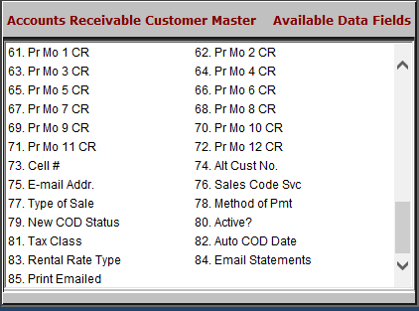

New COD Status: This field shows if the customer has A/R charging privileges.

Active?: This field shows if the customer is active or inactive.
- Tax Class: This field is for California dealers only. It shows an “A” if a customer is an ag customer. Otherwise, it is blank.
- Auto COD Date: This field shows the date after which the customer is automatically set to COD on their account.
- Rental Rate Type: This field shows the customer’s default rental rate type.
- Email Statements: This field concerns the customer’s option to request their statement be emailed to them. It shows:
  - “Y” if the customer’s statement is to be emailed to them
  - “N” if it is not.
- Print Emailed: This field concerns if the customer wants both an emailed and printed version of their statement. It shows:
  - “Y” if the customer’s emailed statement is also to be printed out
  - “N” if it is not.

