Accounts Receivable Customer Comments: This file pulls data from the A/R Customer Comments File.

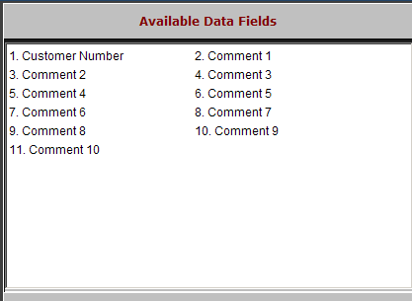

Customer Number: This field holds the five-digit customer number.

Comment 1 – 10: There are ten free-form comment lines for each customer.

