Accounts Receivable History: This file pulls data from the A/R History File.

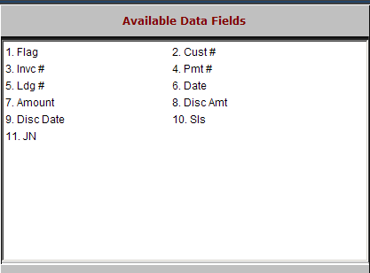

Flag: This field shows one of the following Status Codes:

“I” for Invoice

“P” for Paid.

Cust #: This field shows the customer’s account number and name.

Invc #: This field shows the original invoice number or document number of a manually-entered invoice document.

Pmt #: This field shows the original payment number or document number of the payment.

Ldg #: This field shows the account number affected: 10300 for A/R charges, and other account numbers for Farm Plan or Credit Card transactions.

Date: This field shows the date of the transaction.

Amount: This field shows the amount of the transaction.

Disc Amt: This field is reserved for future use.

Disc. Date: This field is reserved for future use.

Sls: This field shows the initials or code of the person who wrote the original invoice.

JN: This field shows the Journal Number where the invoice or receipt transaction was posted.

