Accounts Receivable Ship To Addresses: This file pulls data from the A/R Ship To Addresses File.

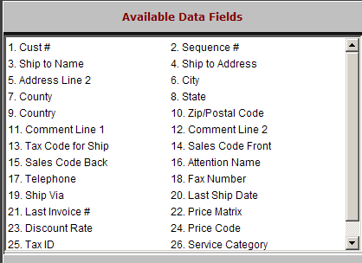

Cust #: This field holds the unique five-digit number for this customer.

Sequence #: This field shows the record number of the ship to address. 0 is for the first record, 1 is for the second, etc.

Ship To Name: This field holds the name for the ship to address.

Ship To Address: This field holds the address.

Address Line 2: This field provides an additional line for the ship to address.

City: This field holds the city.

County: This field holds the county where the customer receives their shipments.

State: This field holds the state where the customer receives their shipments.

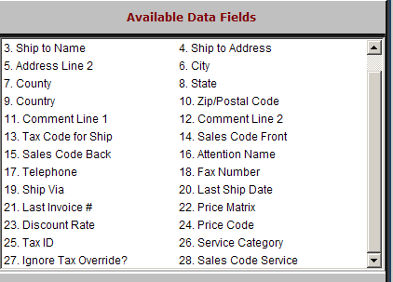

Country: This field holds the country where the customer receives their shipments.

Zip/Postal Code: This field holds the zip code or postal code for the shipping address.

Comment Line 1: This field holds comments about this address, like additional information or special shipping instructions.

Comment Line 2: This field holds comments about this address, like additional information or special shipping instructions.

Tax Code For Ship: This field holds the primary or typical tax code for this ship to address.

Sales Code Front: This field holds the default sales code used when the customer at this ship to address makes purchases at the Parts Counter.

Sales Code Back: This field holds the default sales code used when the customer at this ship to address makes purchases in the Service Department (repair orders).

Attention Name: This field can be used to designate a specific department or person to receive merchandise.

Telephone: This field holds the telephone number for the ship to address.

Fax Number: The field holds the fax number for the ship to address.

Ship Via: This field holds the customer’s preferred shipping method.

Last Ship Date: This field shows the last time an invoice was created for this address.

Last Invoice #: This field shows the last invoice number issued to this address.

Price Matrix: This field is used to point to a defined price matrix code.

Discount Rate: This field may show a pre-set discount for this ship to address.

A positive number means a discount.

A negative number means a bump.

Price Code: The Dealer Defined Pricing field holds the basis for the pricing for the customer. It works with the discount level rate field to determine the selling price for pre-priced items in POS and SMS. The choices for this field are:
  - 1 - Cost
  - 2 - List
  - 3 - Dealer Defined Pricing Level
  - 4 - Dealer Defined Pricing Level
  - 5 - MSRP (Manufacturer’s Suggested)

Tax ID: This field stores the tax exempt number for the customer at this ship to address

Service Category: This field is for future use for shipping addresses in Service Management (SMS).

Ignore Tax Override?: This field allows the customer’s sales tax code to override any codes found on part numbers.

“Y” means the customer’s codes are to be used.

