Parts POS Documents Pre-Journal Post Profit: This file pulls data from POS documents that have been printed on a Profit Report but have not yet been journaled.

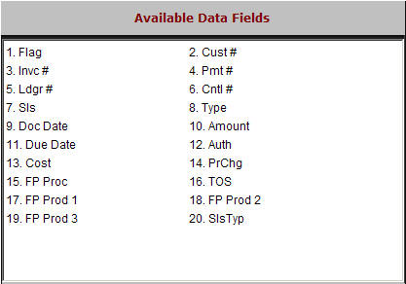

Flag: This field is reserved for future use.

Cust #: This field holds the unique five-digit number for the customer.

Invc #: This field shows the invoice number for the transaction.

Pmt #: This field holds the reference number of the payment, if any.

Ledgr #: This field shows the General Ledger account number where this line of the transaction will be posted.

Cntrl #: This field may hold information if this transaction line is A/R or a sub-ledgered account.

Sls: This field shows the initials or number of the sales person for the invoice.

Type: This field may show a transaction type on some lines (i.e., T – tax, G – total sales).

Doc Date: This field shows the invoice date for the transaction.

Amount: This holds the amount for this line of the transaction.

Due Date: This field may show a due date if the future billing option has been chosen.

Auth: This field may show an authorization code on a credit card, Farm Plan or Ag Line transaction.

Cost: This field may show the cost on this line of the transaction.

PrChg: This field may show an asterisk (*) if the price of this item has been changed on the invoice.

FP Proc: This field may show a value related to a Farm Plan Product Code on a Farm Plan or Ag Line transaction.

TOS: This field may show the type of sale from the POS transaction.

FP Prod 1 – 3: These fields may show the Farm Plan Product Code on a Farm Plan or Ag Line transaction.

SlsTyp: This field may show “P” to note that the transaction was processed in POS.

