General Ledger Detail Accounting Entries: This file pulls data from G/L documents that are in the OPEN accounting period(s) (ENTRY file).

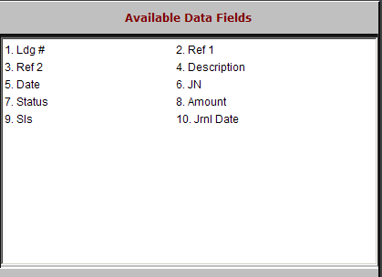

Ldg #: This field shows the General Ledger account number for this line of the transaction.

Ref 1: This field holds the primary reference number or document number for the transaction (Check #, Invoice #, Document #, etc.).

Ref 2: This field shows the Control Number for the transaction. It is usually one of the following:

A stock number

A vendor number

A customer number.

Description: This field shows the description of this transaction line.

Date: This field shows the date entered on the transaction (document date).

JN: This field displays the Journal Number for this line of the transaction.

Status: This field is not currently used. All lines will show 1 here.

Amount: This field shows the amount of the line of the transaction shown.

Sls: POS and WG Sales transactions will show a salesperson’s initials or number in this field.

Jrnl Date: This field show the date the transaction was journaled.

