General Ledger Journal Total Posting File: This file pulls data from Journal Total file (JRNTOT) which holds summary information about G/L activity of OPEN accounting period(s).

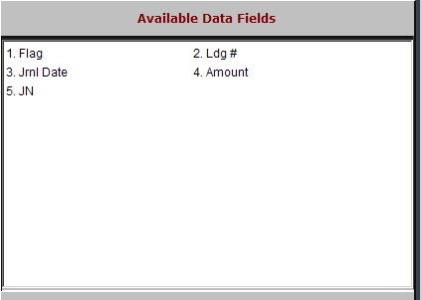

Flag: This field is reserved for future use.

Ldg #: This field shows the general ledger account number.

Jrnl Date: This field holds the date the transactions were journaled.

Amount: This field summarizes the dollars accumulated for the journal and journal date.
- JN: This field shows the journal number used.

