General Ledger History Detail File: This file pulls data used by the G/L Detail program. This G/L documents transaction details for all open AND closed account periods.

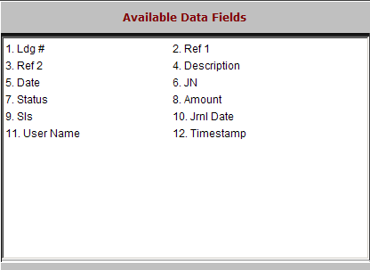

Ldg #: This field shows the General Ledger account number for this line of the transaction.

Ref 1: This field holds the primary reference number or document number for the transaction (Check #, Invoice #, Document #, etc.)

Ref 2: This field shows the Control Number for the transaction. It is usually one of the following:

A stock number

A vendor number

A customer number.

Description: This field shows the description of this transaction line.

Date: This field shows the date physically entered on the transaction (document date).

JN: This field displays the Journal Number for this line of the transaction.

Status: This field is for future use. Currently a 1 will appear on each line.

Amount: This field shows the amount of this line of the transaction.

Sls: POS and WG Sales transactions will show a salesperson’s initials or number in this field.

Jrnl Date: This field shows the date the entry was journaled in the system.

User Name: This field shows the login that ran the journal that posted this transaction.

Timestamp: This field shows the actual physical date the transaction was placed in the system.

