General Ledger History Detail Total File: This file pulls data used by the G/L Detail Total program. This file holds totals for all open AND closed accounting periods.

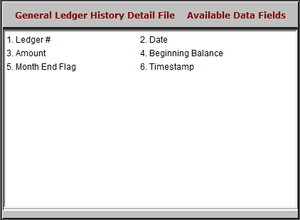

Ledger #: This field shows the General Ledger account number for this line of the transaction.

Date: This field shows the year and month of the detail.

Amount: This field shows the monthly amount for the account.

Beginning Balance: This field holds the running YTD balance for the account.

Month End Flag: This field indicates if the month is closed.

“Y”=Yes

“N”=No.

Timestamp: This field shows the actual date of the last transaction posted to this month.

