General Ledger Balances Forward and History: This file pulls account number, history, budget, and allocation information used in the Account Number Maintenance program (ANM).

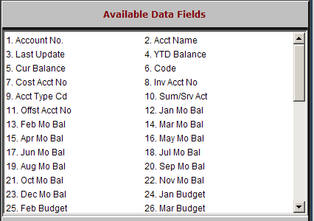

Account No.: This field holds the 5-6 character general ledger account number.

The 6th position is only used for multi-locations.

Acct Name: This field holds the description of the account number.

Last Update: This field holds the date this account was last affected by a month end closing process.

YTD Balance: This field holds the balance as of the last month end closing process. This is a system-maintained field and is updated when an accounting period is closed.

Cur Balance: This field holds the closing balance for the same account period noted in the YTD balance as of the previous year’s business.

Jan – Dec Mo Bal: These 12 fields hold the closing balances of a rolling 12 months. They are updated when the GL month end and year end programs are run.

Jan – Dec Budget: These 12 fields hold budget figures for a rolling 12 months for this account.

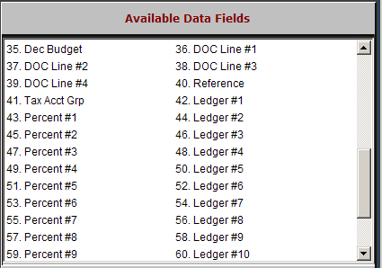

DOC Line #1: This is the first of four fields used in the formatting of the DOC (Daily Operating Control) report. This field holds the line number of the first appearance of this account number on the DOC report.

DOC Line #2: This is the second of four fields used in the formatting of the DOC (Daily Operating Control) report. This field holds the line number of the second appearance of this account number on the DOC report.

DOC Line # 3: This is the third of four fields used in the formatting of the DOC (Daily Operating Control) report. This field holds the line number of the third appearance of this account number on the DOC report.

DOC Line #4: This is the fourth of four fields used in the formatting of the DOC (Daily Operating Control) report. This field holds the line number of the fourth appearance of this account number on the DOC report.

Reference: This field is used to reference an account number from a previous system.

This field can also be used for John Deere dealerships. The entry of the John Deere account number here allows the extraction and submission of financial information to the manufacturer on a monthly basis.

Tax Acct Grp: This field is used to define Sales Tax groups within the accounting system. These groups feed the Sales Tax Group Report, which can be used to complete standard sales tax reports.

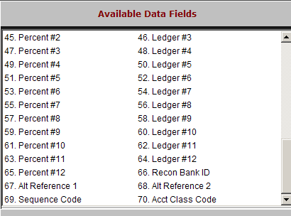

Ledger #1 - #12: This series of fields is used for the expense allocation feature. In these fields, account numbers are entered that will receive the allocated entry passed to this general ledger account.

Percent #1 - #12: This series of fields is used for the expense allocation feature. In these fields, percentages are associated with each general ledger account to note the portion of the allocated entry passed to this general ledger account.

Recon Bank ID: This field is used by the bank reconciliation program to indicate that this account is to be included in the reconciliation process.

Alt Ref Act 1: This field is primarily used for CNH Case Dealers who submit their financial statistics to CNH via their communications package. It holds a CNH account number to cross-reference.

Alt Ref Act 2: This field is primarily used for CNH New Holland Dealers who submit their financial statistics to CNH via their communications package. It holds a CNH account number to cross-reference.

Sequence Code: This field is primarily used by International Truck dealers. It holds a sequence number to sort the chart of accounts.

Acct Class Code: This field is primarily used by International Truck dealers. It holds a reference code for month-end processing.

