Subledger Balances Forward
This file pulls information from the Subledger (SLED) file.

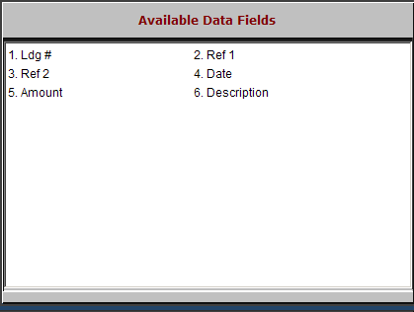

Ldg #: This field holds the five-digit general ledger account number.

Ref 1: This field shows the control number for this line.

Ref 2: This field shows the document number for this line.

Date: This field shows the transaction date.

Amount: This field holds the amount for this transaction line.

Description: This field shows the description, if any, of this transaction line.

