Wholegoods Master: This file pulls information from the Wholegoods Master for New, Used, Sold, Ordered, Rental, Transfer, or Historical units.

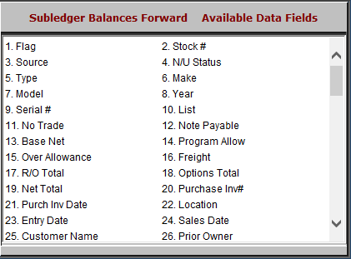

Flag: This field is reserved for future use.

Stock #: This 9-character alpha/numeric field holds the unique identifying number for each individual piece of equipment. Each item entered into the system requires a stock number.

Source: This three-character alpha numeric field holds the Source Number, which ties the Stock Number record to the set of accounts needed for purchase and sales transactions.

N/U Status: This field shows the status of the unit item. The available status types are:

N=New

U=Used

H=Historical

S=Sold

T=Transferred

O=Ordered

R=Rental.

Type: The Type field will show a detailed or generic description of the piece of equipment.

Make: This three-character field identifies the manufacturer or “Make” of the unit.

Model: This field holds the equipment’s Model Number.

Year: This field holds the four-digit model year of the unit.

Serial #: This field holds the unit’s 18-position, alphanumeric main Serial Number.

List:

While the unit is in inventory, this field holds the suggested selling price.

When the unit is sold, this field holds the selling price.

No Trade
  - While the unit is in inventory, this field holds the low-take value.
  - When the unit is sold, it holds the cost of the unit at the time of the sale.

Note Payable: This field shows the amount of notes payable owed on the unit, if any.

Base Net: This is the base cost, or typically the original invoice cost of the unit itself (excluding options, freight and repair orders).

Program Allow: This field can hold the amount of Program Allowance or incentive discount for the unit. NOTE: It is a reference field only and is not used in the calculation of either the cost or selling price.

Over Allowance: This field is system maintained and typically affected when the unit is a trade-in. The sales invoicing routine can place an amount here at the time the unit is being brought in. If you “over-allowed” for a trade-in, that difference becomes the Over Allowance entry for this field.

Freight: This field holds the freight charges for the equipment referenced, if they have been itemized.

R/O Total: This field totals the amount of Repair Orders applied to this unit.

In the case of an inventory unit, it is likely that the repairs are added into the Net Total.

Options Total: This field totals the amount of Options applied to this unit.

In the case of an inventory unit, it is likely that the options are added into the Net Total or total cost of the unit.

Net Total: This field provides the total cost of the inventory unit. Typically it includes the following:

Base Net

Freight

R/O Total

Options Net Total.

Purchase Inv#: This field shows the Manufacturer’s Invoice Number.

Purchase Inv Date: This field goes hand-in-hand with the Invoice Number field. It holds the date for the invoice.

Location: The location field can hold the physical location of the item (i.e., back lot, side yard, front field, showroom).

In a multi-store environment, it can provide the branch location of the unit.

When the unit has been sold or transferred, the system inserts “DELIVERED” in this field.

Units on order show “ON ORDER” in this field.

Entry Date: This system-maintained field shows the date when you entered the Stock Number into the system.

Sales Date: When the unit is sold or transferred, the system records that transaction date as the Sales Date in this field.

Customer Name: When the unit is sold or transferred, the system records the name of the customer in this field.

Prior Owner: This field identifies one of the following:

The company or person who previously owned the equipment, if it was “used”

The manufacturer’s name, if it was entered here when the unit was purchased.

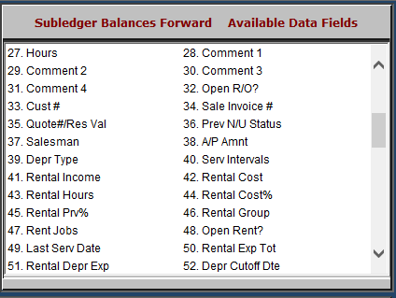

Hours: This field shows the number of Engine Hours that the equipment has accumulated. It is updated from the following systems when the current hours on the unit are entered:

POS

SMS

Rental

Comment 1 – 4: There are four freeform comment lines available for additional information about this item. They can be used for additional descriptions, interest start dates, details of programs/incentive discounts, additional serial numbers, and so on.

Open R/O?:

If there is an open repair order against the unit, this shows “Y.”

Otherwise it shows “N.”

Cust #:

When the unit is in inventory, this field is named Vend # and can show the vendor number of the A/P or Notes Payable amount.

When the unit is sold or transferred, the name changes to Cust # and the system records the number of the customer in this field.

Sale Invoice #: This field shows the invoice number for the sales transaction after the unit is sold.

Quote#/Res Val: This field keeps the number of the last quote generated for this unit.

It may also hold a residual value if the unit has been flagged for depreciation.

Prev N/U Status: This field identifies the unit’s previous status. For example, it might show “N” or “U” if the unit now has been sold.

Salesman: When the unit is sold or transferred, the system records the salesperson’s number or initials here.

A/P Amnt: This field may show an amount owed in Account Payable, if appropriate.

Depr Type: If the unit has been set up for depreciation, this field will show one of the following:

S=Straight Line

Y=Sum of Years

D=Double Decline

E=Expense.

Serv Intervals: This field is reserved for future use.

Rental Income: Rental System only. This field shows accumulated rental income for the unit.

Rental Cost: Rental System only. This field shows accumulated rental cost for this unit.

Rental Hours: Rental System only. This field shows hours the unit has been on rental.

Rental Cost%: Rental System only. This field holds the cost percentage used for rental income transactions.

Rental Prv%: This field is reserved for future use.

Rental Group: This field is reserved for future use.

Rent Jobs: This field is reserved for future use.

Open Rent?: Rental System only.

If there is an open rental contract against the unit, this shows “Y.”

Otherwise, it shows “N.”

Last Serv Date: This field is reserved for future use.

Rental Exp Tot: Rental System only. This field may hold accumulated expense dollars for this unit.

Rental Depr Exp: Rental System only. This field may hold accumulated depreciation dollars for the unit.

Depr Cutoff Dte: This field is reserved for future use.

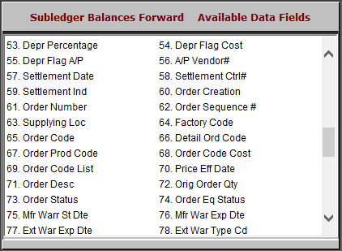

Depr Percentage: Rental System only. This field holds the depreciation percentage used for rental income transactions.

Depr Flag Cost: This field is reserved for future use.

Depr Flag A/P: This field is reserved for future use.

A/P Vendor#: This field may hold the A/P vendor number, if applicable.

Settlement Date: This field shows the settlement date for ordered units.

Settlement Ctrl#: This field shows the document number for settlements of ordered units.

Settlement Ind.: This field can show a settlement indicator code for ordered units.

Order Creation: This field can hold the order date.

Order Number: The 10-character field shows the order number of this units order.

Order Sequence #: This field may show an order sequence number.

Supplying Loc: This 8-character field shows the supplying location for John Deere automated orders.

It can be used to record other order information for manually entered orders.

Factory Code: This field may show a factory code for ordered units.

Order Code: This 12-character field shows the order code for John Deere automated orders.

It can be used to record other order information for manually entered orders.

Detail Ord Code: This 12-character field shows the detail machine order code for John Deere automated orders.

It can be used to record other order information for manually entered orders.

Order Prod Code: This 10 character field shows the product type code for John Deere automated orders.

It can be used to record other order information for manually entered orders.

Order Code Cost: This 10-digit field shows the order cost (dealer price) for the ordered item.

Order Code List: This 10-digit field shows the list price of the ordered item.

Price Eff Date: This field shows the date the ordered prices were established or locked in for John Deere automated orders.

It can be used to record other order information for manually entered orders.

Order Desc: This 36-character field shows the order description.

Orig Order Qty: This field may show the original quantity of the order.

Order Status: This field may show the status of the order.

Order Eq Status: This field shows:

“N” if the unit ordered is new

“U” if the unit ordered is used.

Mfr Warr Start Dt: This field can hold the warranty start date.

Mft Warr Exp Date: This field can hold the warranty expiration date.

Ext Warr Exp Date: This field can hold the extended warranty expiration date.

Ext Warr Type Cd: This field stores an extended warranty type code, if appropriate.

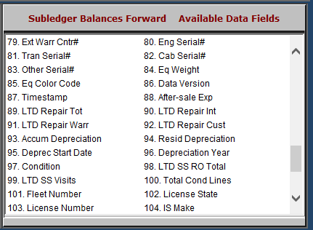

Ext Warr Cntr#: This field can show the extended warranty contract number.

Eng Serial#: This field stores the engine serial number.

Tran Serial#: This field stores the transmission serial number.

Cab Serial#: This field stores the cab serial number.

Other Serial#: This field stores the serial number for any other component of the unit.

Eq Weight: This field stores the unit’s weight.

Eq Color Code: This field holds the color of the unit or the equipment color code.

Data Version: This field is reserved for future use.

Timestamp: This field is reserved for future use.

After-sale Exp: This is the accumulation of after-sale expenses for this stock number

LTD Repair Total: This field shows the lifetime to date total for all repair orders posted to the unit. This includes:

Customer repair orders

Internal repair orders

Warranty repair orders

LTD Repair Int: This field shows the lifetime to date total for internal repair orders posted to the unit.

LTD Repair Warr: This field shows the lifetime to date total for warranty repair orders posted to the unit.

Ltd Repair Cust: This field shows the lifetime to date total for customer paid repairs posted to the unit.

Accum Depreciation: This field is active only if the depreciation function is in use. It may show the accumulated depreciation for this stock number.

Resid Depreciation: This field is active only if the depreciation function is in use. It may show the date depreciation started for this stock number.

Deprec Start Date: This field is active only if the depreciation function is in use. It may show the date depreciation started for this stock number.

Depreciation Year: This field is active only if the depreciation function is in use. It may show the accumulated depreciation for the year for this stock number.

Condition: This field is active only for the Netview Service package. It may show the condition description of the repair order.

LTD SS RO Total: This field is active only for the Netview Service package. It may show life-to-date repair order dollars for this stock number.

LTD SS Visits: This field is active only for the Netview Service package. It may show life-to-date number of times this unit has been in the shop.

Total Cond Lines: This field is active only for the Netview Service package. It may show total number of condition lines on the repair order.

Fleet Number: This field may hold the customer’s own number for the unit.

License State: This field may hold the State or Province of the license plate for this unit.

License Number: This field may hold the License Plate number for the unit.

IS Make: This field holds the IRON Solutions Make.

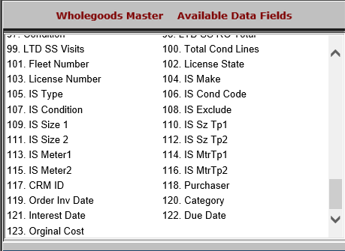

IS Type: This field shows the IRON Solutions Type.

IS Cond Code: This field holds the numeric rating of the used unit’s condition.

IS Condition: This field holds the comments about the unit’s condition.

IS Exclude: This field indicates if the unit should be part of the regular IRON Solutions inventory upload.

If the field shows “Y,” it is excluded from the inventory upload

If the field shows “N,” it is included in the inventory upload.

IS Size 1: This field shows the measurement value for the IRON Solutions Size of the unit.

IS Sz Tp 1: This field defines the value entered in IS Size 1, i.e. inches, feet, pounds, etc.

IS Size 2: This field shows an additional measurement value for the IRON Solutions Size of the unit.

IS Sz Tp 2: This field defines the value entered in IS Size 2, i.e. inches, feet, pounds, etc.

IS Meter 1: This field shows the meter reading for the IRON Solutions meter.

IS Mtr Tp 1: This field defines the value entered in IS Meter 1, i.e. hours, miles, bales, etc.

IS Meter 2: This field shows an additional meter reading for the IRON Solutions meter.

IS Mtr Tp 2: This field defines the value entered in IS Meter 2, i.e. hours, miles, bales, etc.

CRM ID: This field shows the customer number of the unit.
- Purchaser: This field is reserved for future use.
- Order Inv Date: This field shows the order invoice date.
- Category: This field shows the unit's category.
- Interest Date: This field shows the date on which interest will start charging on the unit if it has not been paid off by then.
- Due Date: This field holds the due date for the unit’s invoice, which is the date that the invoice needs to be fully paid-off. This is related to, but not necessarily the same as, the interest date.
- Original Cost: This field holds the original invoice amount for Rental units.

