Wholegoods Source: This file pulls information from the Wholegoods Source Master.

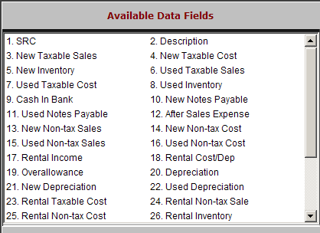

SRC: This field holds the alphanumeric, 3-character Source Number for the selected source.

Description: This field describes the wholegoods source selected.

New Taxable Sales: This field holds the general ledger account where taxable sales of new equipment for this source should be directed.

New Taxable Cost: This field holds the general ledger account where the cost of sales for taxable sales of new equipment for this source should be directed.

New Inventory: This field holds the general ledger account where the inventory of new equipment for this source should be directed.

Used Taxable Sales: This field holds the general ledger account where taxable sales of used equipment for this source should be directed.

Used Taxable Cost: This field holds the general ledger account where the cost of sales for taxable sales of used equipment for this source should be directed.

Used Inventory: This field holds the general ledger account where the inventory of used equipment for this source should be directed.

Cash In Bank: The Cash in Bank field is used at the time of purchasing a wholegood. If you paid for the wholegood (or a portion of it) with a check at the time of purchase, the system will automatically credit the account number shown in this field.

New Notes Payable: This field holds the general ledger account where notes payable amounts for new equipment for this source should be directed.

Used Notes Payable: This field holds the general ledger account where notes payable amounts for used equipment for this source should be directed.

After Sales Expense: This field is used for any expense that is associated with a specific sold unit (i.e. prep for delivery, detail work, oil change, etc.).

New Non-tax Sales: This field holds the general ledger account where nontaxable sales of new equipment for this source should be directed.

New Non-tax Cost: This field holds the general ledger account where the cost of sales for taxable sales of new equipment for this source should be directed.

Used Non-tax Sales: This field holds the general ledger account where nontaxable sales of used equipment for this source should be directed.

Used Non-tax Cost: This field holds the general ledger account where the cost of sales for non-taxable sales of used equipment for this source should be directed.

Rental Income: This field is no longer used.

Rental Cost/Dep: This field is no longer used.

Overallowance: This field holds the general ledger account where the amount of a trade-in over-allowance will be directed.

Depreciation: This field is reserved for future use.

New Depreciation: This field holds the general ledger account where the “debit” or depreciation expense for new equipment for this source should be directed.

Used Depreciation: This field holds the general ledger account where the “debit” or depreciation expense for used equipment for this source should be directed.

Rental Taxable Cost: This field is no longer used.

Rental Non-tax Sale: This field is no longer used.

Rental Non-tax Cost: This field is no longer used.

Rental Inventory: This field holds the general ledger account number for the Inventory Account where the value of the Rental Units for this source is kept.

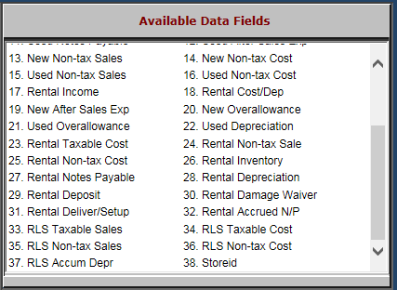

Rental Notes Payable: This field holds the general ledger account number for the Notes Payable Account where the liability of the Rental Units for this source is kept.

Rental Depreciation: This field is no longer used.

Rental Deposit: This field is no longer used.

Rental Damage Waiver: This field is no longer used.

Rental Delivery/Setup: This field is no longer used.

Rental Accrued N/P: This field is no longer used.

RLS Taxable Sales: This field is holds the Sale Account when a Rental Unit from this source is being sold while in the Rental System and the transaction is taxable.

RLS Taxable Cost: This field holds the Cost Account to be used when a Rental Unit from this source is being sold while in the Rental System and the transaction is taxable.

RLS Non-tax Sales: This field holds the Sale Account to be used when a Rental Unit from this source is being sold while in the Rental System and the transaction is nontaxable.

RLS Non-tax Cost: This field holds the Cost Account to be used when a Rental Unit from this source is being sold while in the Rental System and the transaction is nontaxable.

RLS Accum Depr: This field is no longer used.
- Storeid: This field shows the store ID where the Rental Unit was rented from.

