Wholegoods Repair Orders & Options: This file pulls information from the Wholegoods file that stores the details of WG Repair Orders and Options.

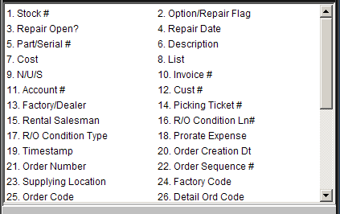

Stock #: This field holds the stock number of the unit.

Option/Repair Flag: This field identifies the type of record, which could be:

R=Repair

O=Option

T=Rental.

Repair Open?
  - If there is an open repair order against this unit, this field shows “Y.”
  - Otherwise, the field shows “N.”

Repair Date: This field shows:

The open date for the transaction while it is open

The closed or billing date when it is closed.

Part/Serial #: This number field holds one of the following:

An option number or serial number for a repair

The contract number for a rental transaction.

Description: This area holds the details of the option, repair order, or rental contract.

Cost: This field can hold the cost of the option, repair, or rental billing.

List: This field can hold one of the following:

The selling price of the option

The sales amount of a rental transaction.

N/U/S: This field may show the status of the unit at the time of the transaction for selected repair orders or options.

Invoice #: This field shows the individual invoice number for this transaction.

Account #: This field may hold the general ledger account number for this transaction.

Cust #: This field will show one of the following:

The customer number

The source transaction line.

Factory/Dealer: This flag shows if the option was installed at the factory (F) or by the dealer (D).

Picking Ticket #: While the Repair Order is open, one of the following will show:

The picking ticket number will show if the Repair Order was opened in POS

The repair order number will show if the repair order was opened in SMS.

Rental Salesman: This field may show the initials of the salesman in a rental transaction.

R/O Condition Ln#: This field is the condition line number of a repair order opened from Service Management.

R/O Condition Type: This field displays the type of repair order being shown. The valid types are:

C=Customer

I=Internal

W=Warranty

Prorate Expense: This field may have an entry if a repair order is opened in SMS.

Timestamp: This field is reserved for future use.

Order Creation Dt: This field can hold the order date.

Order Number: This field shows the order number for this unit.

Order Sequence #: This field may show an order sequence number.

Supplying Location: This 8-character field shows the supplying location for John Deere automated orders.

It can be used to record other order information for manually entered orders.

Factory Code: This field may show a factory code for ordered units.

Order Code: The 12-character field shows the order code for John Deere automated orders.

It can be used to record other information for manually entered orders.

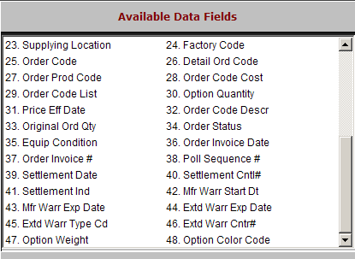

Detail Ord Code: This 12-character field shows the detail machine order code for John Deere automated orders.

It can be used to record other order information for manually entered orders.

Order Prod Code: This 10-character field shows the product type code for John Deere automated orders.

It can be used to record other order information for manually entered orders.

Order Code Cost: This 10-digit field shows the order cost (dealer price) for the ordered item.

Order Code List: This 10 digit field shows the list price of the ordered item.

Option Quantity: This field is reserved for future use.

Price Eff Date: This field shows the date the ordered prices were established or locked in for John Deere automated orders.

It can be used to record other order information for manually entered orders.

Order Code Descr: This 36-character field shows the order code description.

Oiginal Ord Qty: This field may show the original order quantity of the order.

Order Status: This field may show the status of the order.

Equip Condition: This field shows:

“N” if the ordered unit is new

“U” if the ordered unit is used.

Order Invoice Date: This field can hold the order date.

Order Invoice #: This field shows the order number for the unit.

Poll Sequence #: This field is reserved for future use.

Settlement Date: This field shows the settlement date for John Deere automated orders.

It can be used to record other order information for manually entered orders.

Settlement Cntl#: This field shows the document number for settlement of ordered units.

Settlement Ind: This 2-character field shows the settlement indicator code for John Deere automated orders.

It can be used to record other order information for manually entered orders.

Mfr Warr Start Dt: This field holds the warranty start date.

Mfr Warr Exp Date: This field holds the warranty expiration date.

Extd Warr Exp Date: This field shows the extended warranty expiration date.

Extd Warr Type Cd: This stores an extended warranty type code, if appropriate.

Extd Warr Cntr#: This field stores the extended warranty contract number.

Option Weight: This field stores the weight of the option.

Option Color Code: This field stores the color or color code of the option.

