Wholegoods POS History: This file pulls information from the Wholegoods POS History file of Wholegoods sales.

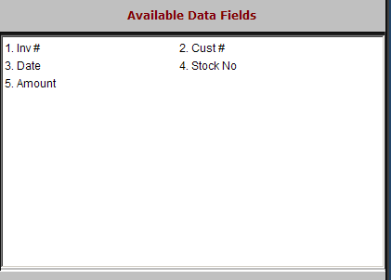

Inv: This field shows invoice numbers.

Cust #: This field shows customer numbers for the sales transactions.

Date: This field shows the invoice creation date.

Stock No: This field lists the stock number for the unit(s).

Amount: This field shows the invoice amount for the unit.

