Accounts Payable Vendors: This file pulls information from the A/P Vendor file.

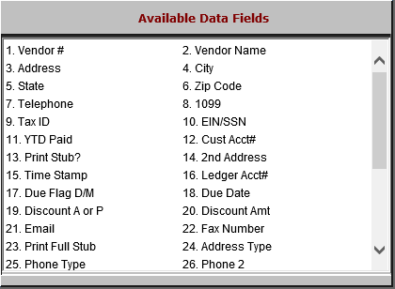

Vendor #: The vendor number is a 5-character (numeric) field.

Vendor Name: This field holds the vendor’s company name, or individual’s name if a contractor.

Address: This field holds the vendor’s address.

City: This field holds the vendor’s city.

State: This field holds the vendor’s state or province.

Zip Code: This field holds the vendor’s 5 or 9-digit zip code or Canadian postal code.

Telephone: This field holds the vendor’s telephone number without the dashes.

1099: This field holds one of the following:

“Y” if the vendor should receive a 1099.

“N” if the vendor does not receive a 1099.

Tax ID: This field holds the vendor’s federal identification type, which can be:

EIN (Employer Identification Number)

SSN (Social Security Account Number).

EIN/SSN: This field holds the 1099 ID (E or S).

YTD Paid: This field shows the YTD paid to the vendor for this calendar year.

Cust Acct#: This field holds the dealership’s customer account number with this vendor.

Print Stub?: This field shows the preference for printing the check stubs for this vendor.

“Y” to print stubs

“N” to skip them.

2nd Address: This field provides a second line for the address, should it require one.

Time Stamp: This field is reserved for future use.

Ledger Acct#: This field holds the default general ledger account for purchases from this vendor.

Due Flag D/M: This field shows how to handle the due date for this vendor.

“D” means the due date is a number of days from the invoice date.

“M” means that the due date is a certain day of the month.

Due Date:
  - If the Due Flag is “M,” a day of the month will be in this field.
  - If the Due Flag is “D,” a number of days will be in this field.

Discount A or P: If the vendor typically provides a discount, this field may show one of the following:

“A” if it is an amount

“P” if it is a percentage.

Discount Amt: This field may display Discount Amount or Discount Percent if the vendor typically provides a discount.
- Email: This field shows the vendor’s email address.
- Fax Number: This field shows the vendor’s fax number.
- Print Full Stub: This field indicates whether or not this vendor will receive a full stub report with their checks.
- Address Type: This field is reserved for future use.
- Phone Type: This field shows what the phone number’s type is:
  - Cell
  - Home
  - Work
- Phone 2: This field shows a second phone number for the vendor, if one exists.
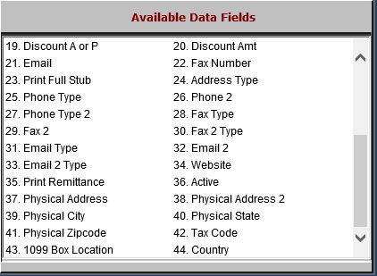

- Phone Type 2: This field shows what the second phone number’s type is:
  - Cell
  - Home
  - Work
- Fax Type: This field shows what the fax number’s type is:
  - Home
  - Work
  - Other
- Fax 2: This field provides a second fax number for the vendor, if available.
- Fax 2 Type: This field shows what the second fax number’s type is:
  - Home
  - Work
  - Other
- Email Type: This field shows the email address’s type:
  - Personal
  - Business
- Email 2: This field shows a second email address for the vendor, if available.
- Email 2 Type: This field shows the second email address’s type:
  - Personal
  - Business
- Website: This field shows the vendor’s website address, if available.
- Print Remittance: This field indicates whether or not the vendor will receive a remittance report with their checks.
- Active: This field indicates if the vendor is currently marked active or inactive in the system.
- Physical Address: This field is reserved for future use.
- Physical Address 2: This field is reserved for future use.
- Physical City: This field is reserved for future use.
- Physical State: This field is reserved for future use.
- Physical Zipcode: This field is reserved for future use.
- Tax Code: If the vendor is Canadian, this field will hold the vendor’s default tax code.
- 1099 Box Location: This field shows which box on the 1099 form the information should be placed in.
- Country: This field shows the vendor’s country of location.

