Accounts Payable Invoices: This file pulls information from the A/P Open Invoices file.

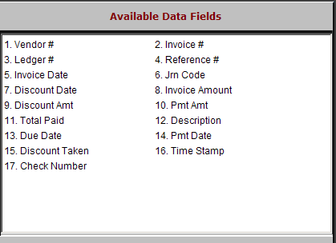

Vendor: This field holds the vendor’s number.

Invoice #: This field holds the invoice/reference number.

Ledger #: This field holds the general ledger account where the purchase from this vendor is directed.

Reference #: This is an optional freeform text field and is not required unless the offset account number is posted to Subledger.

In that case, it may show a stock number or customer name.

Invoice Date: This field holds the invoice date.

Jrn Code: This field displays the status of the invoice, which could be:

E=Entered

J=Journaled

P=Paid
  - S=Selected

Discount Date: This field shows the last date the invoice can be paid to receive the discount.

Invoice Amount: This field shows the invoice amount.

Discount Amt: This field shows the flat amount or calculated discount amount.

Pmt Amt: This field shows the amount of the payment made.

Total Paid: This field shows the total amount paid on this invoice.

Description: This field may show an invoice description of a payment or other information relating to the invoice.

Due Date: This field shows the due date for the invoice.

Pmt Date: This field shows the payment date.

Discount Taken: This field may show an amount if a discount was taken when it was paid.

Time Stamp: This field shows the actual physical date of the invoice or payment.

Check Number: This field shows the check number of the payment.

