Accounts Payable History: This file pulls information from the A/P History File.

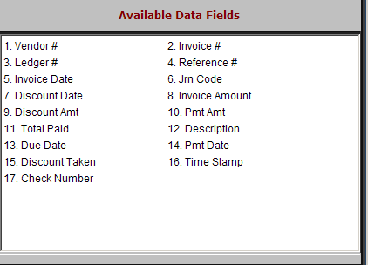

Vendor #: This field holds the vendor number.

Invoice #: This field holds the invoice/reference number.

Ledger #: This field holds the general ledger account where the purchase from this vendor was directed.

Reference #: This field may hold additional information about the invoice, like a stock number, customer number or customer name.

Invoice Date: This field holds the invoice date.

Jrn Code: This field displays the status of the invoice, which could be:

E=Entered

J=Journaled

P=Paid

S=selected

Discount Date: This field shows the last date the invoice can be paid to receive the discount.

Invoice Amount: This field shows the invoice amount.

Discount Amt: This is the total amount of the discount if the invoice is paid by the discount date.

Pmt Amt: This field shows a full or partial payment amount.

Total Paid: This field shows the total amount paid on this invoice.

Description: This field may show an invoice description, details of a payment, or other information relating to the invoice.

Due Date: This field shows the due date of the invoice.

Pmt Date: This field shows the payment date.

Discount Taken: This field may show an amount if a discount was taken when the invoice was paid.

Time Stamp: This field shows the actual physical date of the invoice or payment.

Check Number: This field shows the number of the check used for payment.

