Service Equipment Master File: This file pulls information from the Service Management service equipment file.

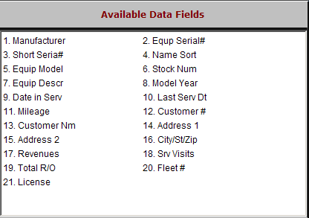

Manufacturer: This three-character field holds the manufacturer or make.

Equp Serial #: This field holds the main serial number of the unit.

Short Seria#: This field holds the last eight characters of the serial number.

Name Sort: This field holds the information from the Alphasort field in the Customer Master.

Equip Model: This field shows the model number of the unit.

Stock Num: This field shows the stock number for this unit.

Equip Descr: This field holds the manufacturer, model year, and model number.

Model Year: The field shows the model year of the unit.

Date In Serv: This field can hold the date the unit went into service.

Last Serv Dt: This system-maintained field displays the date of the last repair work on this unit

Mileage: This field shows the hours or miles on the meter as of the last time the unit was in for service.

Customer #: This shows the customer number of the owner of the unit.

Customer Nm: This field shows the customer’s name.

Address 1: This field shows the customer’s address.

Address 2: This field shows the second line of the customer’s address.

City/St/Zip: This field shows the customer’s city, state/province, and ZIP/Postal Code.

Revenues: This field shows the total value of service work done on this unit.

Srv Visits: This field holds the total number of times this unit has been in the shop.

Total R/O: This field keeps the total number of repairs or conditions that have been done on this unit.

Fleet #: This is 12 character field that can hold a customer’s “fleet name or number” for the unit, such as #12, Unit 14, Tractor 7, etc.
- License: This field shows the license tag/plate number for the equipment to be repaired.

