Service Manufacturer Control File: This file pulls information from the Service Management manufacturer control file.

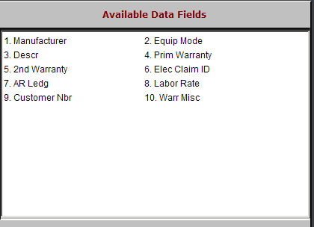

Manufacturer: This three-character field holds the manufacturer or make.

Equip Mode: This field shows the equipment model number.

Descr: There are two types of information that appear here.

For the base manufacturer record (no model number entered), the name or description of the manufacturer is shown.

When both a manufacturer and model number are present, then this field shows a description of the type of equipment.

Prim Warranty: This field shows the manufacturer code.

2nd Warranty: This field is not typically used.

Elec Claim ID: This is not an active field.

AR Ledg: This field holds the General Ledger account to be used for warranty Receivables for this manufacturer.

Labor Rate: This is the hourly rate at which this manufacturer reimburses you for warranty labor.

Customer Nbr: This field should contain the customer number for THIS manufacturer in the Customer file.

Warr Misc: This field contains one of the following:

“Y” if miscellaneous shop charges should apply to Warranty Repair Orders

“N” if they do not.

