Service Repair Order Control File: This file pulls information from the Service Management repair order control file.

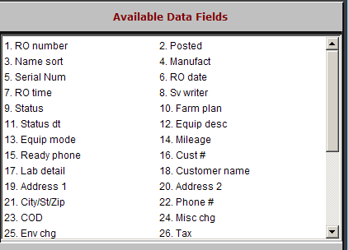

RO number: This field holds the repair order number.

Posted: This field is reserved for future use.

Name Sort: This field may contain a portion of the customer’s name.

Manufact: This field holds the manufacturer of the unit in for repair.

Serial Num: This 20-character field shows the equipment serial number.

RO Date: This field shows the date the repair order was entered into the system.

RO time: This field shows the time the repair order was entered into the system.

Sv writer: This field shows the mechanic’s ID for the service writer of this repair order.

Status: This field shows the status of the repair order. Valid status codes are:

W=Working,
  - C=Completed
  - I=Invoiced
  - S=Settled
  - P=Posted

Farm plan: This field is reserved for future use.

Status dt: This field shows the date this repair order’s status changed.

Equip desc: This field shows the manufacturer, model year, and model number.

Equip Mode: This field shows the unit’s model number.

Mileage: This field shows the hours or miles on the meter.

Ready Phone: This field can show the customer’s phone number.

Cust #: This field shows the customer number of the party responsible for the charges on the repair order.

Lab detail: This field is reserved for future use.

Customer name: This field shows the customer’s name.

Address 1: This area shows the customer’s shipping/mailing address.

Address2: This is the second line of the customer’s address information.

City/St/Zip: This area holds the customer’s city, state/province, and Zip Code/Postal Code.

Phone: This area holds the customer’s phone number.

COD: This field indicates whether the customer is on COD status.

“Y” indicates the customer is on COD status.

“N” indicates the customer is NOT on COD status.

Misc chg: This field indicates if this repair order is subject to miscellaneous charges.

“Y” means the repair is eligible for miscellaneous charges.

“N” indicates the repair order is not eligible for miscellaneous charges.

Env Chg: This field determines if this repair order is subject to environmental charges.

“Y” means this repair is eligible for environmental charges.

“N” indicates the repair order is not subject to an environmental charge.

Tax: This field indicates if a customer R.O. is subject to tax.

Y=Yes

N=No

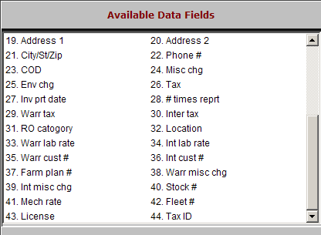

Inv prt date: This is the date the invoice was printed.

# times reprt: This field shows how many times the invoice has been reprinted.

Warr tax: This field shows if a warranty R.O. is subject to tax.

Y=Yes

N=No.

Inter tax: This field indicates if an internal R.O is subject to tax.

Y=Yes

N=No

RO category: The R.O. category indicates the type of taxing, tax rates, and GL account number to be used.

Location: This field is reserved for future use.

Warr lab rate: This field shows the hourly rate for warranty labor.

Int lab rate: This field shows the hourly rate for internal labor.

Warr cust #: This field shows the customer number used for warranty pricing.

Int cust #: This field shows the customer number used for internal pricing.

Farm plan #: This field shows the Farm Plan number, if any, for the customer.

Warr misc chg: This field shows one of the following:

“Y” if the warranty RO is eligible for miscellaneous charges

“N” if it is not eligible.

Int misc chg: This field shows one of the following:

“Y” if the internal RO is eligible for miscellaneous charges

“N” if it is not eligible.

Stock #: This field shows the stock number being repaired.

Mech rate: This field shows the internal rate to be billed, which could be:

B=mechanic’s billable rate

P=mechanic’s pay rate

N=the internal rate

Fleet #: This field can hold the customer’s fleet number for the unit being repaired.

License: This field holds the license number.

Tax ID: This field may show the customer’s tax ID.

