Service Repair Order Parts File: This file pulls information from the Service Management repair order parts file.

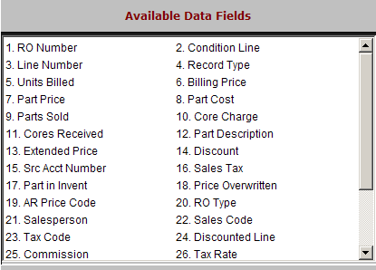

RO Number: This field shows the repair order.

Condition Line: This field shows the condition line the part is posted to.

Line Number: This field shows the line number the part was added to.

Record Type: This field shows a number that indicates the record type.

1=parts

3=comment lines.

Units Billed: This field shows the parts quantity sold.

Billing Price: This field shows the price billed for the part.

Part Price: This field shows the list price of the part.

Part Cost: This field shows the cost of the part.

Parts Sold: This field shows the parts quantity sold.

Core Charge: This field shows the core charge associated with the part.

Cores Received: This field shows the number of cores received.

Parts Description: This field shows the description of the part.

Extended Price: This field shows the extended selling price, which is the quantity times the selling price.

Discount: This field is reserved for future use.

Src Acct Number: This is the 3-digit source code associated with the part number.

Sales Tax: This field is reserved for future use.

Part in Invent: This field indicates if the part is a stocking part or non-stock item.

Price Overwritten: This field indicates if the parts price has been overwritten.

AR Price Code: This is price code that applies to this customer.

RO Type: This field is reserved for future use.

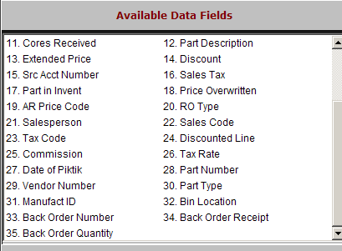

Salesperson: This field shows the initials or number of the salesperson.

Sales Code: This field shows the Sales Code entered on this condition of the repair order.

Tax Code: This field shows the Tax Code entered on this condition of the repair order.

Discounted Line: This field is reserved for future use.

Commission: This field is reserved for future use.

Tax Rate: This field is reserved for future use.

Date of Piktik: This field is reserved for future use.

Part Number: This field shows the part number added to the repair order.

Vendor Number: This field shows the vendor number of the part number.

Part Type: This field shows the part type, which is one of the following:

N=New

U=Used

R=Remanufactured

C=Core

M=Memo

Manufact Id: This field shows the manufacturer ID of the part number.

Bin Location: This field shows the primary bin location of the part number.
- Back Order Number: This field shows the back order number.
- Back Order Receipt: This field shows the back order receipt number.
- Back Order Quantity: This field lists the back order quantity.

