Rental Categories File: This file pulls information from the Rental Management rental categories file.

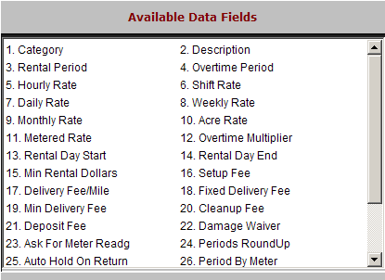

Category: This field holds the abbreviation/code of the rental category.

Description: This field holds the name of the rental category.

Rental Period: This field holds the default rental period for the category.

Overtime Period: This field holds the default overtime period for the category.

Hourly Rate: This field shows the hourly rate for this category.

Shift Rate: This field shows the shift rate for this category.

Daily Rate: This field shows the daily rate for this category.

Weekly Rate: This field shows the weekly rate for this category.

Monthly Rate: This field shows the monthly rate for this category.

Acre Rate: This field shows the per acre rate for this category.

Metered Rate: This field shows the metered rate for this category.

Overtime Multiplier: This field holds the value of overtime if the time past the return time is to be higher than a standard rate (i.e., 1.5).

Rental Day Start: This field holds the time the rental business opens for the day.

Rental Day End: This field holds the time the rental business closes for the day.

Min Rental Dollars: This field may hold a minimum rental amount for units in this category.

Setup Fee: This field may hold a setup fee that is pre-filled as units from this category are added to a rental contract.

Delivery Fee/Mile: This field may hold a delivery fee (per mile charge) that is pre-filled as units from this category are added to a rental contract.

Fixed Delivery Fee: This field may hold a fixed delivery fee that is pre-filled as units from this category are added to a rental contract.

Min Delivery Fee: This field may hold a minimum delivery fee that is pre-filled as units from this category are added to a rental contract.

Cleanup Fee: This field may hold a cleanup fee that is pre-filled as units from this category are added to a rental contract.

Deposit Fee: This field may hold a deposit fee that is pre-filled as units from this category are added to a rental contract.

Damage Waiver: This field may hold a damage waiver fee that is pre-filled as units from this category are added to a rental contract.

Ask for Meter Readg: This field holds “Y” if units in this category should be prompted for a meter reading.

It can also be set to “N” if there is no meter.

Periods RoundUp
- This field holds “Y” if the rental period for units in this category should be rounded up to determine the final bill. It can also be set to “N” if they should not be rounded up.

Auto Hold On Return: This field asks if the unit should automatically be placed on hold when it is returned from a rental (for service work or clean up).

“Y” means it will be placed on hold.

“N” means it will not be placed on hold.

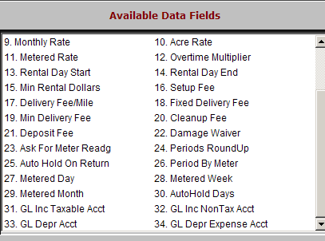

Period by Meter: This field holds the setting to indicate if this unit’s rental period should be determined by the meter reading.

“Y” means it is determined by the meter reading.

“N” means it is not determined by the meter reading.

Metered Day: This field may hold the length of a metered day.

Metered Week: This field may hold the length of a metered week.

Metered Month: This field may hold the length of a metered month.

AutoHold Days: This field may hold the number of days to release a rental unit after it has been returned and placed on hold.

GL Inc Taxable Acct: This field holds the account number where table rental income from this category should be directed.

GL Inc NonTax Acct: This field holds the account number where non-taxable rental income from this category should be directed.

GL Depr Acct: This field holds the account number where depreciation from this category should be directed.

GL Depr Expense Acct: This field holds the account number where the depreciation expense from this category should be directed.

