Rental Taxing Authority File: This file pulls information from the Rental Management rental taxing authority file (tax info).

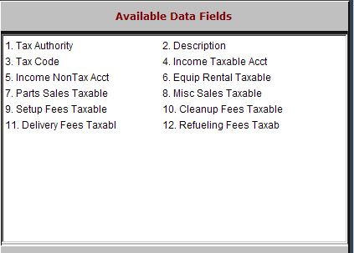

Tax Authority: This field shows the name or number of the tax authority.

Description: This field gives the description of the tax authority.

Tax Code: This field shows the tax code reference to the POS tax rates.

Income Taxable Acct: This field may hold the general ledger account where taxable income from this tax authority should be directed. This is usually left blank.

Income NonTax Acct: This field may hold the general ledger account where non-taxable income from this tax authority should be directed. This is usually left blank.

Equip Rental Taxable: Is rental income taxable under this authority? The field will show one of the following in answer:

Y=Yes

N=No

D=Default to the contract set-up

Parts Sales Taxable: This field is not in use at this time.

Misc Sales Taxable: Are the taxable miscellaneous charges taxable under this authority? The field will show one of the following in answer:

Y=Yes

N=No

D=Default to the contract set-up

Setup Fees Taxable: Is the setup fee taxable under this authority? The field will show one of the following in answer:

Y=Yes

N=No

D=Default to the contract setup

Cleanup Fees Taxable: Is the cleanup fee taxable under this authority? The field will show one of the following in answer:

Y=Yes

N=No

D=Default to the contract setup

Delivery Fees Taxabl: Is the delivery fee taxable under this authority? The field will show one of the following in answer:

Y=Yes

N=No

D=Default to the contract set-up

Refueling Fees Taxab: Is the refueling fee taxable under this authority? The field will show one of the following in answer:

Y=Yes

N=No

D=Default to the contract set-up

