Rental Expense Incurred File: This file pulls information from the Rental Management rental expenses file.

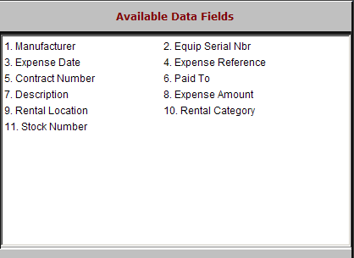

Manufacturer: This field shows the manufacturer code of the rental unit.

Equip Serial Nbr: This field shows the main serial number of the unit.

Expense Date: This field shows the date entered when the rental equipment expense was recorded.

Expense Reference: This field may hold a document number or reference for the expense.

Contract Number: This field may hold the rental contract number, if appropriate.

Paid To: This information indicates the vendor or the party paid when the expense was recorded.

Description: This field shows the description of the rental unit entered when the unit was transferred into the rental fleet.

Expense Amount: This field shows the amount of the expense.

Rental Location: This field will show the location where the rental unit is headquartered (loc1, loc2, etc).

Rental Category: This field shows the rental category to which this unit belongs.

Stock Number: This field shows the stock number of the unit.

