Rental Miscellaneous Items File: This file pulls information from the Rental Management miscellaneous items file.

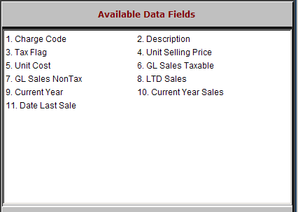

Charge Code: This field shows the charge code for this miscellaneous item.

Description: This field holds the description of the charge.

Tax Flag: This field holds the setting for the sales tax of this charge, which can be:

A=Always taxable
  - N=Never taxable
  - D=Default to customer’s tax rate

Unit Selling Price: This field may hold the selling price of this charge.

Unit Cost: This field may hold the cost of this charge.

GL Sales Taxable: This field will show the General Ledger amount to be used when a taxable sale of the charge occurs.

GL Sales NonTax: This field will show the General Ledger account to be used when non-taxable sale of the charge occurs.

LTD Sales: This field holds the amount of lifetime to date sales for this charge.

Current Year: This field shows the current year.

Current Year Sales: This field holds the amount of current year sales for this charge.

Date Last Sale: This field shows the date of the last sale.

