Rental Contract File: This file pulls information from the Rental Management rental contract file.

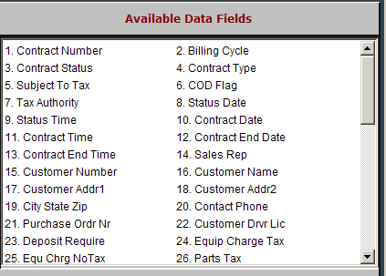

Contract Number: This field holds the rental contract number.

Billing Cycle: This field holds the billing cycle selected for the rental contract, which could be:

Weekly

BiWeekly

Monthly

Quarterly

Contract Status: This field shows the contract status, which could be:

O=Open

C=Closed (unit back, but some billing remains to be done)

H=Historical (unit back and all billing done).

Contract Type: This field shows the type of contract, which could be:

R=Rental

L=Lease

Subject To Tax: This field indicates if the contract is taxable or not.

Y=Taxable

N=Non-taxable.

COD Flag: This shows if the customer is on COD status.

Y=On COD

N=Not on COD.

Tax Authority: This field shows the tax authority in place for the contract.

Status Date: This field shows the date the status of this contract was last checked.

Status Time: This field shows the time the status of this contract was last checked.

Contract Date: This field shows the date the rental contract was opened.

Contract Time: This field shows the time of day the rental contract was opened.

Contract End Date: This field shows the date the equipment for this rental contract was returned.

Contract End Time: This field shows the time of day the equipment for this rental contract was returned.

Sales Rep: This area holds the salesman’s initials or number.

Customer Number: This field holds the customer number for the customer who is renting the equipment.

Customer Name: This field shows the name of the customer renting the equipment.

Customer Addr1: This field shows the first line of the customer’s address.

Customer Addr2: This field shows the second line of the customer’s address.

City State Zip: This area holds the customer’s city, state/province abbreviation and zip code/postal code.

Contact Phone: This field holds the customer’s phone number.

Purchase Order Nr: If this customer provides a PO number, it shows in this field.

Customer Drvr Lic: This field can hold the customer’s driver’s license number.

Deposit Require: If there were any deposits amounts required, they will show in this field.

Equipment Charge Tax: This field may hold the General Ledger account where taxable rental income should be directed.

Equ Chrg NoTax: This field may hold the General Ledger account where non-taxable rental income should be directed.

Parts Tax: This field may hold the General Ledger account where taxable parts sales should be directed. This field is currently not in use.

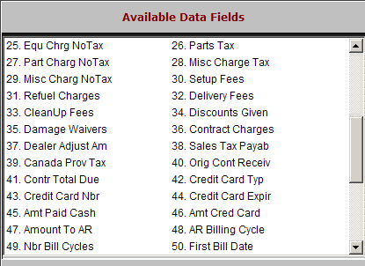

Part Charg NoTax: This field may hold the General Ledger account where non-taxable parts sales should be directed. This field is currently not in use.

Misc Charge Tax: This field may hold the General Ledger account where taxable miscellaneous charges should be directed.

Misc Charg NoTax: This field may hold the General Ledger account where non-taxable miscellaneous charges should be directed.

Setup Fees: This field may hold the General Ledger account where set up fees should be directed.

Refuel Charges: This field may hold the General Ledger account where refueling charges should be directed.

Delivery Fees: This field may hold the General Ledger account where delivery fees should be directed.

CleanUp Fees: This field may hold the General Ledger account where clean up fees should be directed.

Discounts Given: This field may hold the General Ledger account where discounts given should be directed.

Damage Waivers: This field may hold the General Ledger account where damage waiver fees should be directed.

Contract Charges: This field may hold the General Ledger account where the contract charges (i.e. A/R 10300) should be directed.

Dealer Adjust Am: This field may hold the General Ledger account where any dealer adjustment amounts should be directed.

Sales Tax Payab: This field may hold the General Ledger account where sales tax collected should be directed.

Canada Prov Tax: This field may hold the General Ledger account where provincial sales tax collected should be directed.

Orig Cont Receiv: This field may hold the total amount of the original contract.

Contr Total Due: This field may hold the total contract amount due.

Credit Card Typ: If a credit card will be used on the contract, this field may identify the type of card.

Credit Card Nbr: If a credit card will be used on the contract, this field may specify the credit card number.

Credit Card Expir: If a credit card will be used on the contract, this field may specify the credit card expiration date.

Amt Paid Cash: This field may specify the amount of cash paid toward the contract total.

Amt Cred Card: This field may specify the amount of credit card payment paid toward the contract total.

Amount To AR: This field may specify the amount of accounts receivable paid toward the contract total.

AR Billing Cycle: This field shows the billing cycle selected for the contract, which can be:

Weekly

BiWeekly

Monthly

Quarterly

Nbr Bill Cycles: This field shows the number of A/R billing cycles that have been processed for this contract.

First Bill Date: This field will show the first billing date for the contract, if any.

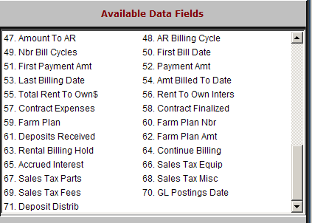

First Payment Amt: This field will show the first payment for the contract, if any.

Payment Amt: This field will show the ongoing payment amount for the next and following billings.

Last Billing Date: This field will show the last time the contract was billed, if any.

Amt Billed To Date: This field shows the amount that has been billed to the contract thus far.

Total Rent To Own: This field shows the amount of the rent to own contract.

Rent To Own Inters: This field shows the interest rate for the rent to own contracts.

Contract Expenses: This field shows the amount of expenses booked to the contract.

Contract Finalized: This field is reserved for future use.

Farm Plan: This field shows the General Ledger account to receive any farm plan amounts.

Farm Plan Nbr: This field may hold the customer’s farm plan account number.

Deposits Received: This field shows the sum of any deposits received.

Farm Plan Amt: This field may hold the amount of this contract that is to be billed to Farm Plan.

Rental Billing Hold:
  - If this unit is on billing hold, you will find “Y” here.
  - If you find “N,” the contract is being billed as usual.

Continue Billing:
  - If the contract is eligible for continuous billing, you will find “Y” here.
  - If it is not, you will see “N.”

Accrued Interest: This field holds the General Ledger account where any interest accrued should be directed.

Sales Tax Equip: This field is reserved for future use.

Sales Tax Parts: This field is reserved for future use.

Sales Tax Misc: This field is reserved for future use.

Sales Tax Fees: This field is reserved for future use.

GL Postings Date: This field may hold the date of the last General Ledger entries made for this contract.

Deposit Distrib: This field may hold the General Ledger account where any deposit that will be kept should be directed.

