Rental Equipment File: This file pulls information from the Rental Management rental equipment file.

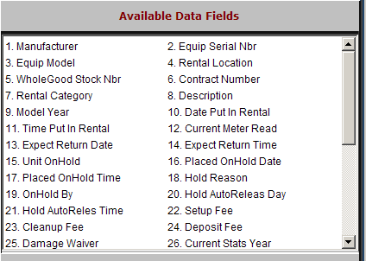

Manufacturer: This field shows the manufacturer of the rental/rent-to-own unit.

Equip Serial Nbr: This field shows the main serial number of the unit.

Equip Model: This field shows the model number for the piece of equipment.

Rental Location: This field displays the location of rental (i.e. loc1, loc2, etc).

WholeGood Stock Nbr: This field shows the stock number assigned to the unit.

Contract Number: This field shows the contract number if a contract is currently opened for the unit.

Rental Category: This field shows the rental category of the rental/rent-to-own unit.

Description: This field shows the description of the rental unit entered when the unit was transferred into the rental fleet.

Model Year: This field shows the model year of the rental item.

Date Put In Rental: This field displays the date the item was defined as a rental piece.

Time Put In Rental: This field displays the time the item was defined as a rental piece.

Current Meter Read: This field shows the meter reading when the unit went out on rental.

Expect Return Date: This field displays the date the rental unit is expected back.

Expect Return Time: This field displays the time the rental unit is expected back.

Unit OnHold: This field indicates if the unit is on hold.

“Y” means there is a hold

“N” means there is not a hold in force

Placed OnHold Date: If there is a hold on the unit, this field shows the date the hold was placed.

Placed OnHold Time: If there is a hold on the unit, this field shows the time of day the hold was placed.

Hold Reason: If there is a hold on the unit, this field shows the reason for the hold.

OnHold By: If there is a hold on the unit, this field shows the person who created the hold.

Hold AutoReleas Day: If there is a hold on the unit, this field shows the date the hold should auto release.

Hold AutoReles Time: If there is a hold on the unit, this field shows the time of day the hold should auto release.

Setup Fee: This field may hold a pre-set setup fee for this rental unit.

Cleanup Fee: This field may hold a pre-set clean up fee for this rental unit.

Deposit Fee: This field may hold a pre-set deposit for this rental unit.

Damage Waiver: This field may hold a pre-set damage waiver amount for this rental unit.

Current Stats Year: This field may hold the current year designation for rental statistics.

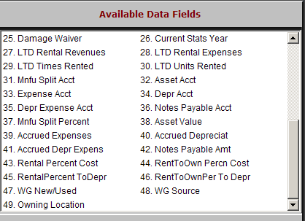

LTD Rental Revenues: This field will show the life-time-to-date rental revenue for this unit.

LTD Rental Expenses: This field will show the life-time-to-date rental expenses for this unit.

LTD Times Rented: This field will show the number of times the unit has been rented life-time-to-date.

LTD Units Rented: This field will show the number of units the unit has generated life-time-to-date.

Mnfu Split Acct: This field is reserved for future use.

Asset Acct: This field shows the General Ledger account where the asset value for this rental unit is kept.

Expense Acct: This field shows the General Ledger account where expenses for this rental unit are directed.

Depr Acct: This field shows the General Ledger account where depreciation accumulated for this rental unit is directed.

Depr Expense Acct: This field shows the General Ledger account where the depreciation expense for this rental unit is directed.

Notes Payable Acct: This field shows the General Ledger account where the notes payable value for this rental unit is kept.

Mnfu Split Percent: This field is reserved for future use.

Asset Value: This field shows the asset value for this rental unit.

Accrued Expenses: This field shows the accrued expenses for this rental unit.

Accrued Depreciat: This field shows the accrued depreciation for this rental unit.

Accrued Depr Expens: This field shows the depreciation expense for this rental unit.

Notes Payable Amt: This field shows the notes payable amount for this rental unit.

Rental Percent Cost: This field shows the percentage to use when the rental income is costed.

RentToOwn Percn Cost: This field shows the percentage to use when the rent-to-own income is costed.

RentalPercent ToDepr: This field shows the percentage to use when the rental income is depreciated.

RentToOwnPer To Depr: This field shows the percentage to use when the rent-to-own income is depreciated.

WG New/Used: This field holds the former status of the unit while it was in Wholegoods Inventory.

WG Source: This field stores the unit’s wholegoods source.

Owning Location: This field shows the owning location of the rental unit.

