AGCO Finance Manager Manufacturer Codes File: This file pulls information from the AGCO Finance Manager Manufacturer Codes File.

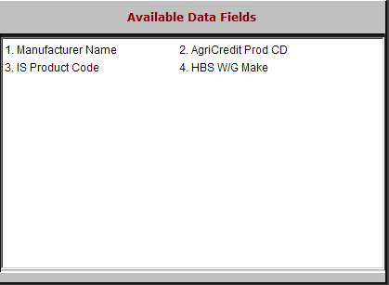

Manufacturer Name: This field holds the manufacturer name. The information in this field is AGCO-provided information.

AgriCredit Prod CD: This field holds the AgriCredit Product Code. Any information in this field is AGCO-provided information.

IS Product Code: This field holds up to a five-character code for the type of equipment within a category.

HBS Units Make: This field shows the information in the make field on the HBS Business System.

