AGCO Finance Manager Product Codes File: This file pulls information from the AGCO Finance Manager Product Codes File.

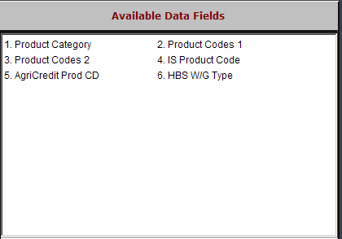

Product Category: The information in this field is AGCO-provided information.

Product Codes 1: This field holds the Product Code within the Product Category. The information in this field is AGCO-provided information.

Product Codes 2: This field holds an additional Product Code within the Product Category. The information in this field is AGCO-provided information.

IS Product Code: This field holds the IS Product Code. The information in this field is AGCO-provided information.

AgriCredit Prod CD: This field holds the AgriCredit Product Code. The information in this field is AGCO-provided information.

HBS W/G Type: This field shows the information in the Type field on the HBS Business System.

