IRON Solutions Wholegoods Make Codes File: This file pulls information from the IRON Solutions Wholegoods Make Codes File.

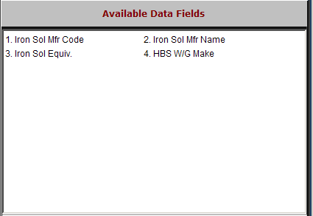

Iron Sol Mfr Code: This field holds the manufacturer code. The information in this field is IRON solutions-provided information.

Iron Sol Mfr Name: This field holds the Manufacturer name. The information in this field is IRON Solutions-provided information.

Iron Sol Equiv.: The information in this field is IRON Solutions-provided information.

HBS W/G Make: This field shows the information in the Make field on the HBS Business System.

