IRON Solutions Wholegoods Product Type Codes File: This file pulls information from the IRON Solutions Wholegoods Product Type Codes File.

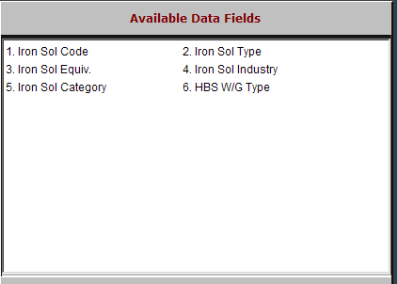

Iron Sol Code: This field holds a five-character type code. The information in this field is IRON Solutions-provided information.

Iron Sol Type: This field holds the Product Type or description. The information in this field is IRON Solutions-provided information.

Iron Sol Equiv.: This field holds the Iron Solutions equivalent. The information in this field is IRON Solutions-provided information.

Iron Sol Category: This field holds the Iron Solutions Product Category. The information in this field is IRON Solutions-provided information.

HBS W/G Type: This field shows the information in the Type field on the HBS Business System.

