Kubota Showroom Manufacturer Codes File: This file pulls information from the Kubota Showroom Manufacturer Codes File.

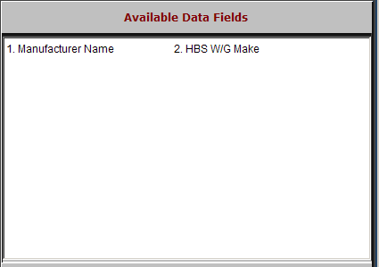

Manufacturer Name: This field holds the five-character code for the manufacturer (make). The information is this field is Kubota showroom-provided information.

HBS W/G Make: This field shows the information in the Make field on the HBS Business System.

