Kubota Showroom Product Type Codes File: This file pulls information from the Kubota Showroom Product Type Codes file.

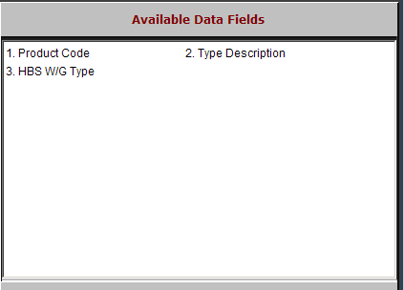

Product Code: This field holds up to a five-character code for the type of equipment within a category.

Type Description: This field shows the type description.

HBS W/G Type: This field shows the information in the Type field on the HBS Business System.

