Service Standard Labor Charges File: This field pulls information from the Standard Labor Charges (SLC) File.

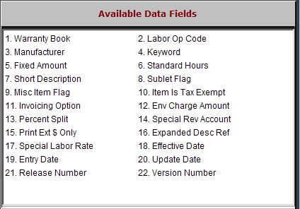

Warranty Book: This field holds the designation for DEALER or MISCITEM if there is no manufacturer identified.

If there is a manufacturer present, it will show that manufacturer here.

Labor Op Code: This field holds the Op code defined.

Manufacturer: This field may hold the manufacturer code.

Keyword: This is a 16-character field for a keyword or shortcut to identify the Op Code.

Fixed Amount: If there is a fixed dollar amount to be billed for this particular labor operation, you may find that in this field.

Standard Hours: If this is a warranty labor operation or if there is a reference to the manufacturer’s guideline for the number of hours, you may find the number of standard hours in this field.

Short Description: This 36-character field holds a brief description of the repair to be done.

Sublet Flag: Is this labor sublet labor?

“Y” indicates that it is sublet labor.

“N” means it is not.

Misc Item Flag: Is this a miscellaneous item?

“Y” indicates that it is a miscellaneous item.

“N” means it is not.

Item Is Tax Exempt: Is this labor always tax exempt?

“Y” indicates that it is always non-taxable.

“N” means it is a taxable charge.

Invoicing Option: The choices for this field are:

A=Always print this detail

N=Never print this detail

S=Standard print logic. S is a standard setting.

Env Charge Amount: This field holds a dollar amount for an environmental charge associated with this Op Code.

Percent Split: This field may show a percentage which splits the revenue generated from this labor operation to two different revenue or sales accounts in the General Ledger.

Special Rev Account: This field may hold the General Ledger account to receive charges from this op code.

If the percentage split field is used, this field is used as one of the two numbers to receive percentage charges.

Print Ext $ Only: This setting offers the option to show full extension of the labor detail when displayed or printed.

“N” means the time applied to this condition will be shown with the number of hours and the labor rate plus the extended price for labor.

“Y” in this field shows only the extended price for labor, and does not show or print the number of hours or labor rate.

Expanded Desc Ref: This field may show a reference to a field in another file that contains an expanded description.

Special Labor Rate: This field may hold a different or special labor rate applied to this op code.

Effective Date: This informational field shows the date the labor charge definition was created.

Entry Date: This field shows the date the labor charge definition was added to the system.

Update Date: This is an inactive field reserved for future use.

Release Number: This field is reserved for future use.

Version Number: This field is reserved for future use.

