Parts POS Documents Pre-Profit: This field pulls information from the Parts POS Documents Pre-Profit File.

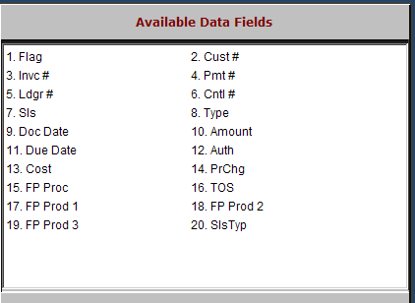

Flag: This field is reserved for future use.

Cust #: This field prints the customer’s number for the specific invoice.

Invc #: The report prints the invoice number assigned by POS.

Pmt #: This field may show a payment reference for ROA’s handled in POS.

Ldgr #: This field prints the General Ledger account number where the item shown has been posted.

Cntl #: This field may show a customer number or other reference based on the transaction line.

Sls: This field shows the salesman’s initials or number.

Type: This field shows a transaction type on source lines (i.e., T=tax, G=form of payment).

Doc Date: This field shows the invoice date for the transaction.

Amount: This field holds the amount for this line of the transaction.

Due Date: This field holds the date payment is due for the specific invoice if the future billing option was selected.

Auth: This field may show an authorization code on a credit card, Farm Plan, or Ag Line transaction.

Cost: This field may show the cost on this line of the transaction.

PrChg: This column prints an asterisk (*) if a salesperson has manually changed something about this line on the invoice.

FP Proc: This field may show a value related to a Farm Plan product code.

TOS: This field may show the type of sale from the POS transaction.

FP Prod 1 – 3: These fields may show the Farm Plan product code on a Farm Plan or Ag Line transaction.

SlsTyp: This field may show “P” to note that the transaction was processed in POS.

